North Dakota 1915(i) Group Provider Enrollment Guide

Last Revised: May 23, 2022
This guide is not a substitute for official guidance from the North Dakota Department of Human Services.

Table of Contents
Table of Contents 1
Introduction 2
How to Use this Guide 2
Before Getting Started 2
Group Enrollment Step A: North Dakota MMIS Web Portal 4
Initiating the Application 4
1. Identifying Information 5
2. Licensure / Certification 6
3. Provider Identifier Numbers 8
4. Service Location Information 9
5. Affiliations 13
6. Electronic Transaction Submission 14
7. Ownership 15
8. Authorized Representatives 16
9. Exclusions / Sanctions 17
10. Qualified Service Providers 18
Submitting the Application 19
Pulling Up an Incomplete Application & Checking Application Status 22
Group Enrollment Step B: PDF Forms 23
REQUIRED: 1. Coversheet for Fax/Email 23
REQUIRED: 2. Group Application Checklist 25
POSSIBLE: 3. List of Service Locations 27
REQUIRED: 4. W-9 27
POSSIBLE: 5. CP 575/147C 27
POSSIBLE: 6. IRS Tax Exempt Letter 27
REQUIRED: 7. Group Attestation 27
REQUIRED: 8. Group License/Certification 29
REQUIRED: 9. NPI Printout from the NPPES Website 30
REQUIRED: 10. SFN 661: Electronic Funds Transfer 30
POSSIBLE: 11. SFN 509: Out of State/Out of Network Enrollment Clarification 32
REQUIRED: 12. SFN 1168: Ownership/Controlling Interest and Conviction Information 34
REQUIRED: 13. SFN 615: Medicaid Program Provider Agreement 37

Introduction
This document serves as a guide to the group provider enrollment process for enrolling to provide 1915(i) services, specifically Housing Support Services, through the North Dakota Department of Human Services (ND DHS). This guide was created by Ei-Consultants and CSH, who are providing technical support to 1915(i) providers and prospective 1915(i) providers. This guide is not a substitute for official guidance from DHS. Please reference the ND DHS 1915(i) Provider Enrollment Process Overview webpage for more information. The 1915(i) provider enrollment process is subject to change. Please check the ND DHS 1915(i) website for the most up-to-date information. Ei-Consultants and CSH will work to keep this guide as current as possible.

After completing the group provider enrollment process (i.e., the process to enroll your agency as a 1915(i) provider), you will need to enroll each staff member at your agency who will be providing 1915(i) services via the individual provider enrollment process. Ei-Consultants and CSH will be creating a separate guide for individual provider enrollment. The ND DHS 1915(i) Provider Enrollment Process Overview webpage includes information and guidance regarding the individual provider enrollment process.

How to Use this Guide
This guide provides a walkthrough of the requirements for provider enrollment for agencies enrolling to become Housing Supports providers. This process is referred to as the group application/group provider enrollment. This process requires two steps, which do not need to be submitted in a particular order. One step is to complete the provider enrollment application within the North Dakota MMIS Web Portal. The other step is to complete PDF forms (listed on the Provider Enrollment Checklist) and email or fax them to DHS’s 1915(i) Provider Enrollment. This guide uses a fictional nonprofit organization as an example for how to complete the forms.

After enrolling your agency, you will need to enroll the individual providers providing 1915(i) services. This guide does not cover the provider enrollment process for individual providers providing 1915(i) services.

An overview of the 1915(i) provider enrollment process from DHS is available here.

Before Getting Started
Before getting started, you will need to obtain a National Provider Identifier Number (NPI). Both agencies and individual providers can obtain an NPI via the National Plan & Provider Enumeration System (NPPES) website. For Housing Supports, the taxonomy code you should use when signing up for an NPI number for your agency is 251S00000X - Community/Behavioral Health. For Care Coordination, the taxonomy code you should use for your agency is 251B00000X - Case Management. You can select multiple taxonomy codes when obtaining an NPI if needed. For a full list of possible 1915(i) taxonomy codes for agencies, please refer to the ND Medicaid - Group Provider Type, Specialty and Taxonomy Valid Values document from DHS.

Although this guide does not cover individual provider enrollment, please note that each staff member who will be providing 1915(i) services will need to obtain their own NPI number. The taxonomy codes for individuals are different from the taxonomy codes for groups. For Housing Supports and Care Coordination, the taxonomy code individuals should use when signing up for an NPI number for individuals is 171M00000X - Case Manager/Care Coordinator. You can select multiple taxonomy codes when obtaining an NPI if needed. For a full list of possible 1915(i) taxonomy codes for individuals, please refer to the ND Medicaid - Individual Provider Type, Specialty and Taxonomy Valid Values document from DHS.

Group Enrollment Step A: North Dakota MMIS Web Portal
Your agency will need to go through the group provider enrollment process on the North Dakota MMIS Web Portal. This section walks you through the process with screenshots of the MMIS Web Portal. You do not need to complete this process prior to completing the PDF forms; however, you must at least initiate this process before submitting the PDF forms because the PDF forms ask for the application tracking number that is generated when you begin the process of group provider enrollment in the MMIS Web Portal.

The process is completely electronic, so all answers must be exactly correct. In particular, agency name must EXACTLY match the agency name on Federal Tax Forms. There is no room for typographical errors or mistakes in this process, as the system will send you back to the beginning of the process and you will need to repeat sections over.

DHS has provided a guide for going through the provider enrollment process in the MMIS Portal, which is available here. Screenshots from the DHS guide are included in this guide for your convenience. The MMIS Portal also includes guidance and information in the beige column on the left.

Initiating the Application
Access the MMIS Web Portal Provider Enrollment page and select “Group Provider Enrollment.”
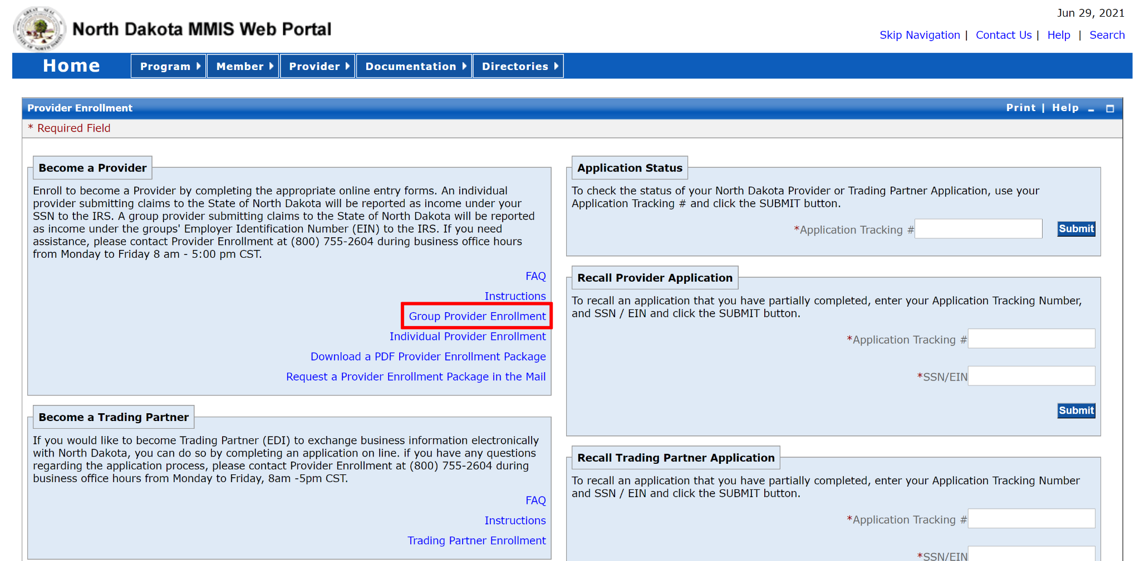

Read the instructions and click “Continue.”
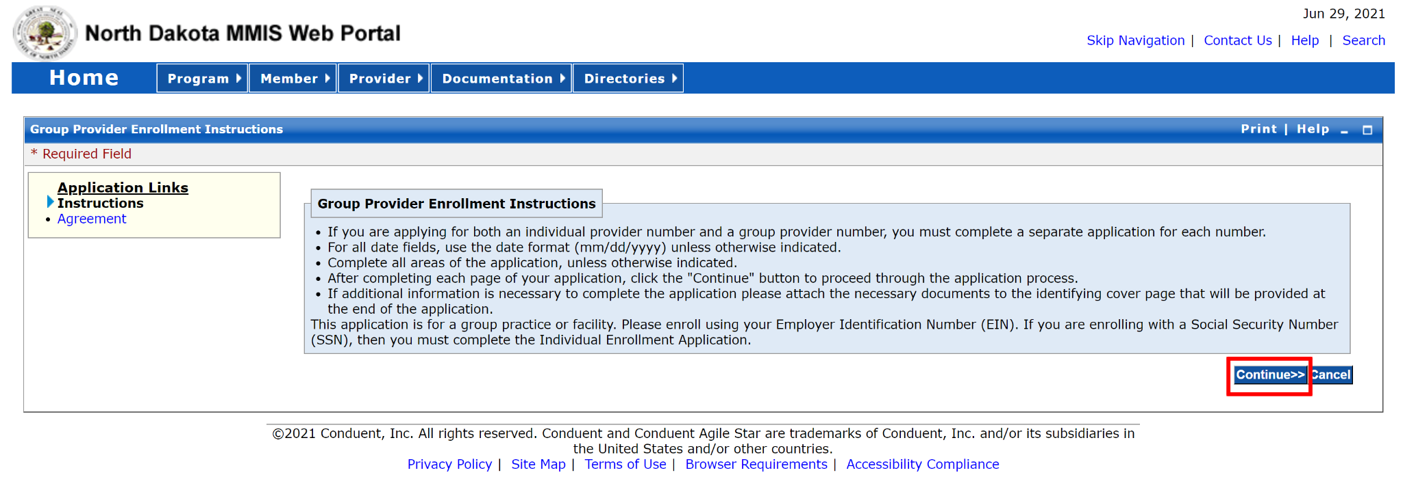

Read the Provider Acknowledgement and select “Accept.”
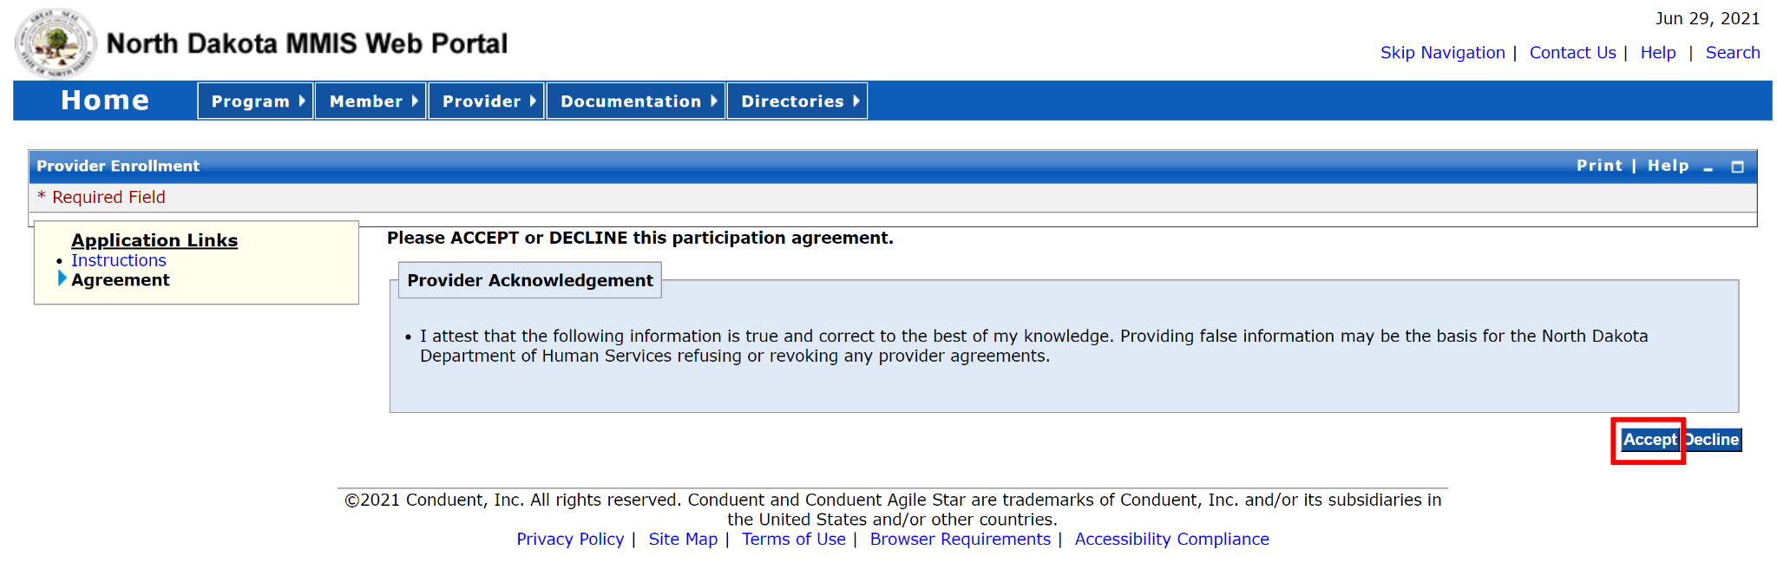

1. Identifying Information
Complete the Identifying Information as appropriate for your agency, following the guidance from the DHS application guide.
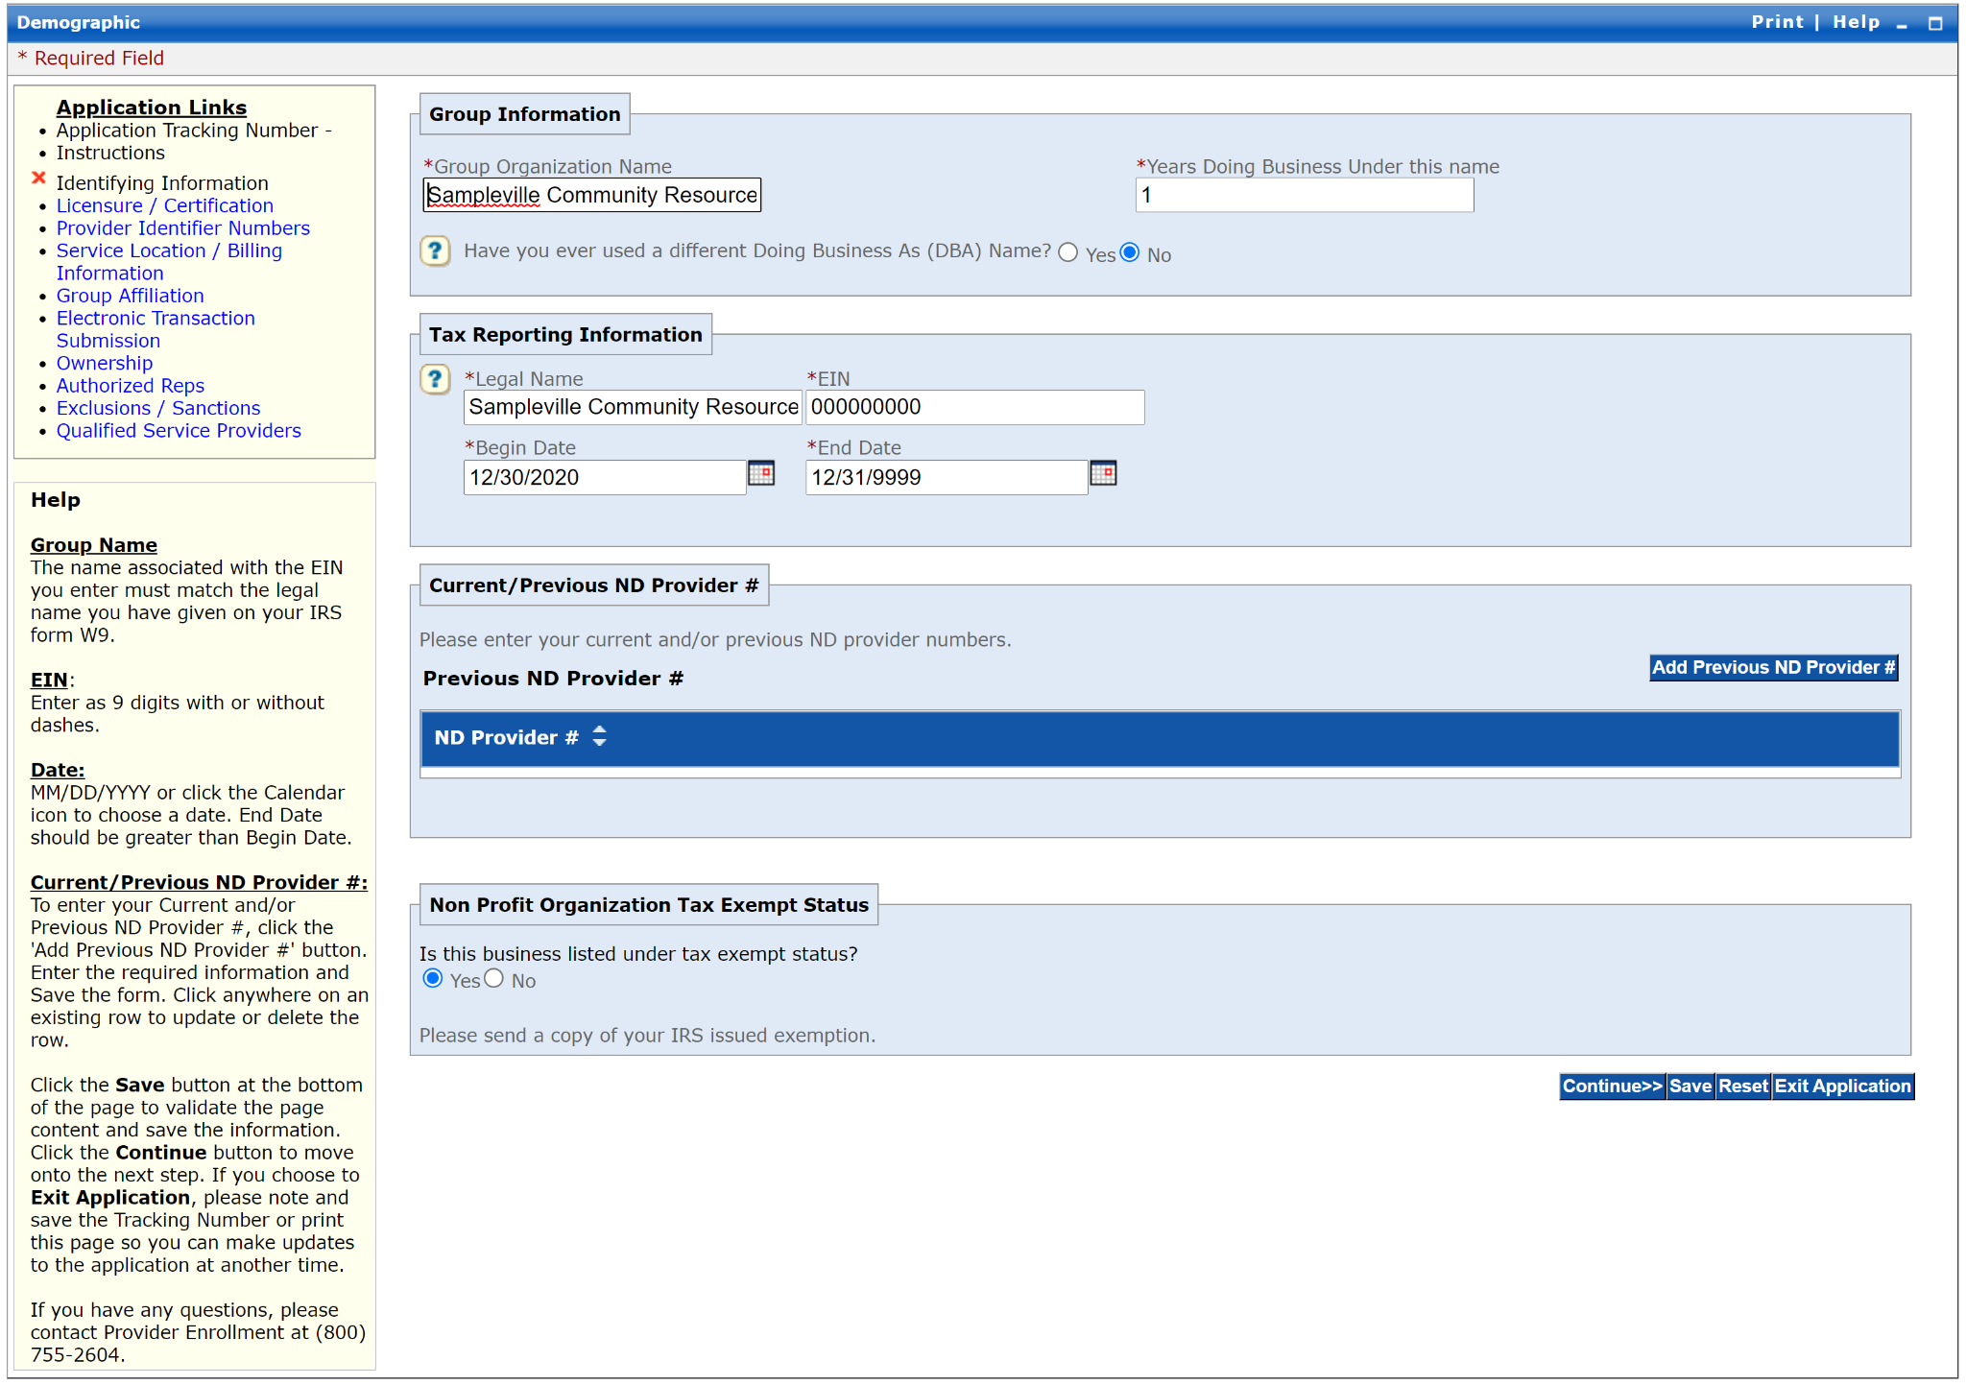

DHS guidance:
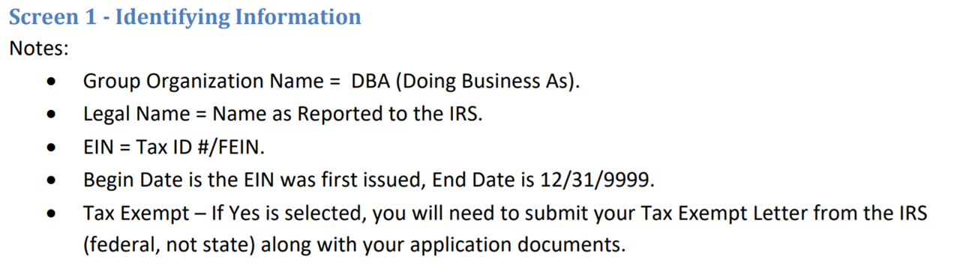

2. Licensure / Certification
On the Licensure / Certification page, select “1915i State Plan Amendment Services” as the Provider Type. For the Licensure and Certification List, enter “DUM00000” for the License Number because no license or certification is required for 1915(i) services. You will need to add all 1915(i) services you plan to provide in the Speciality List. You will also need to enter the proper Taxonomy Codes for those services. A list of the specialties and taxonomy codes are available here.

Also note that you should now see an Application Tracking Number at the top of the left column (blacked out in the screenshot below). This number will be needed when completing the PDF forms.

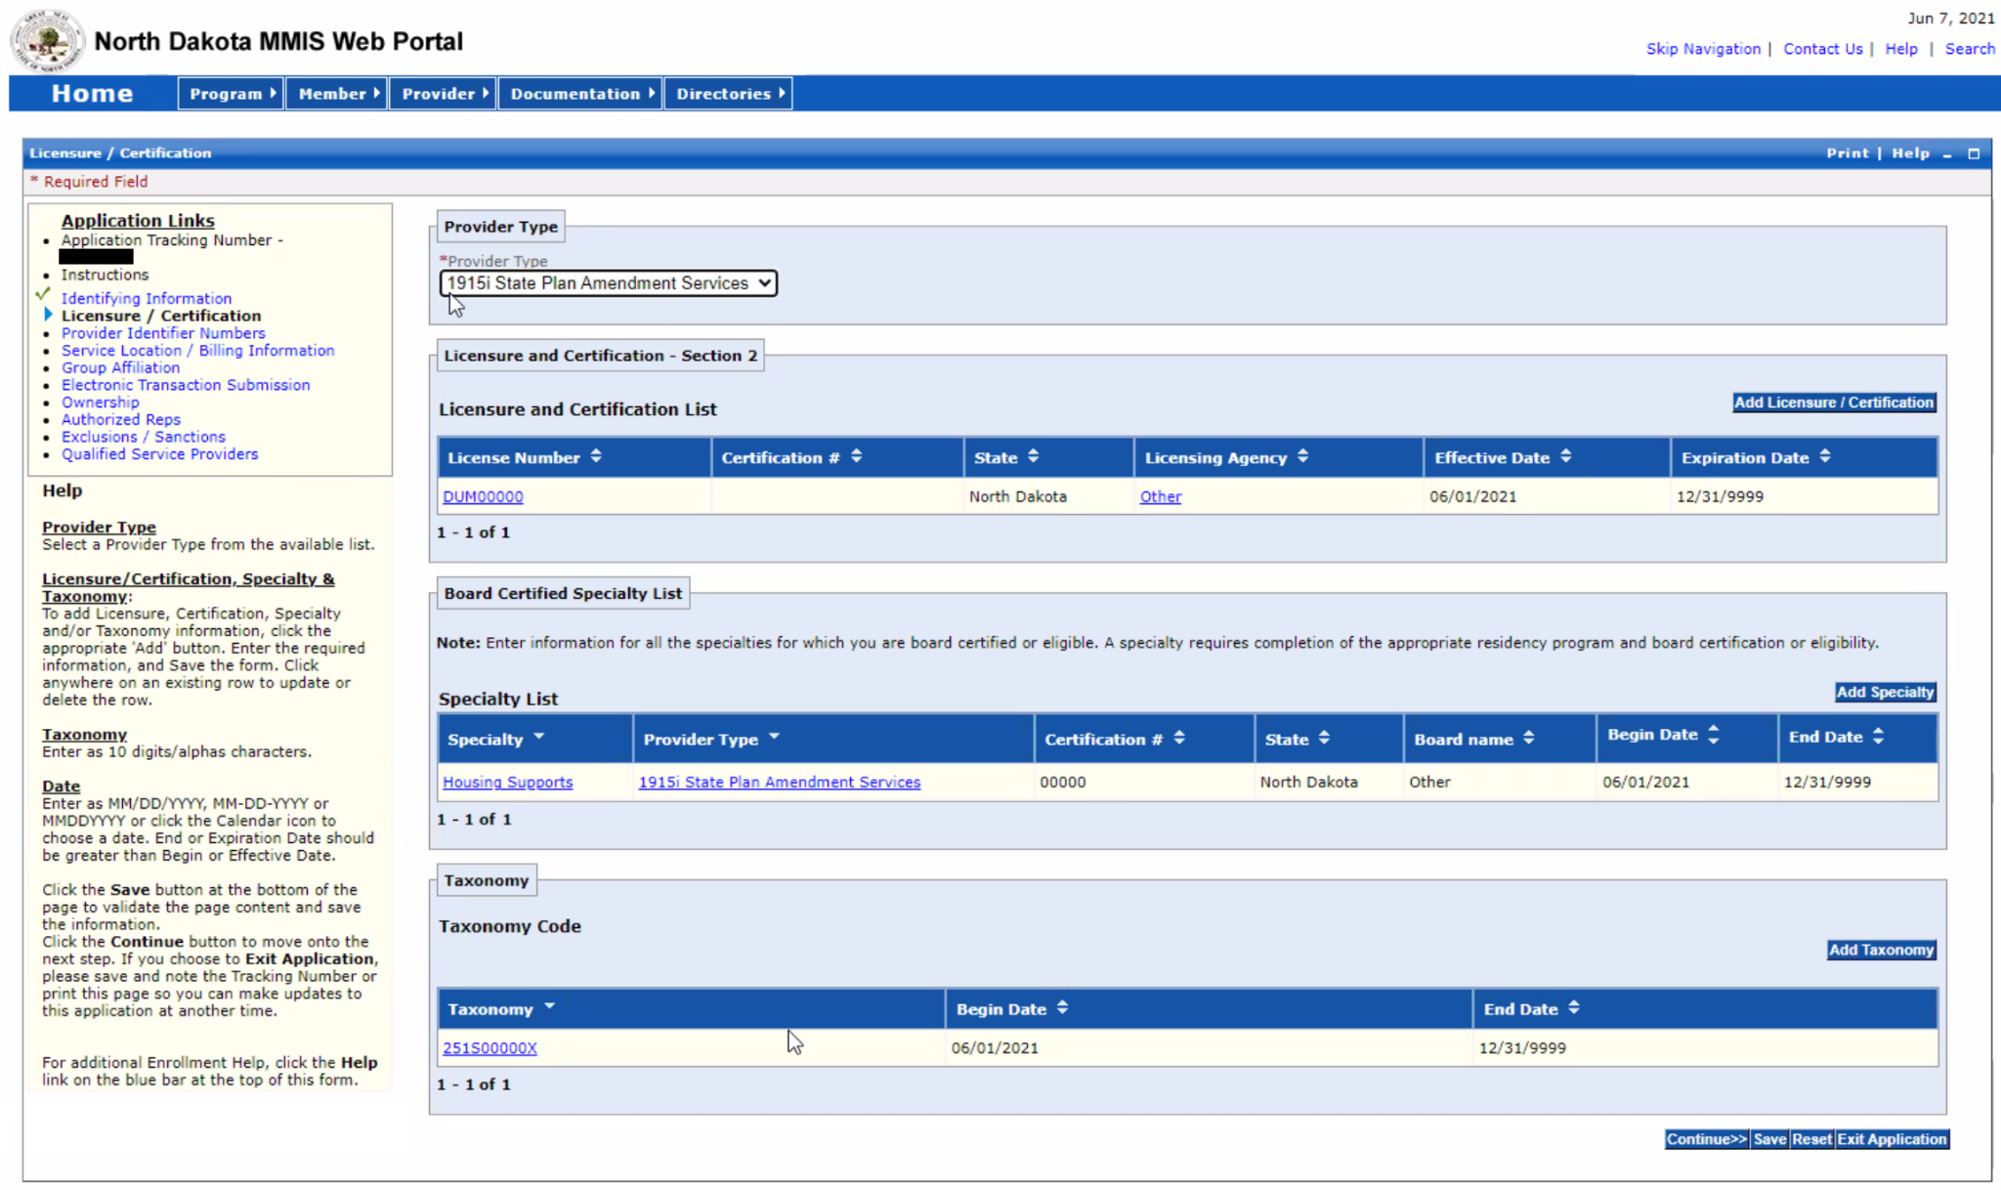

DHS Guidance:
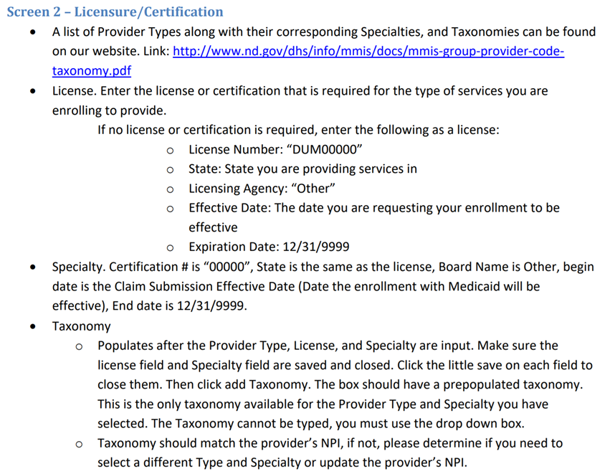

3. Provider Identifier Numbers
On this screen, you will need to enter your agency’s NPI number. Answer the rest of the questions and sections as appropriate for your agency.
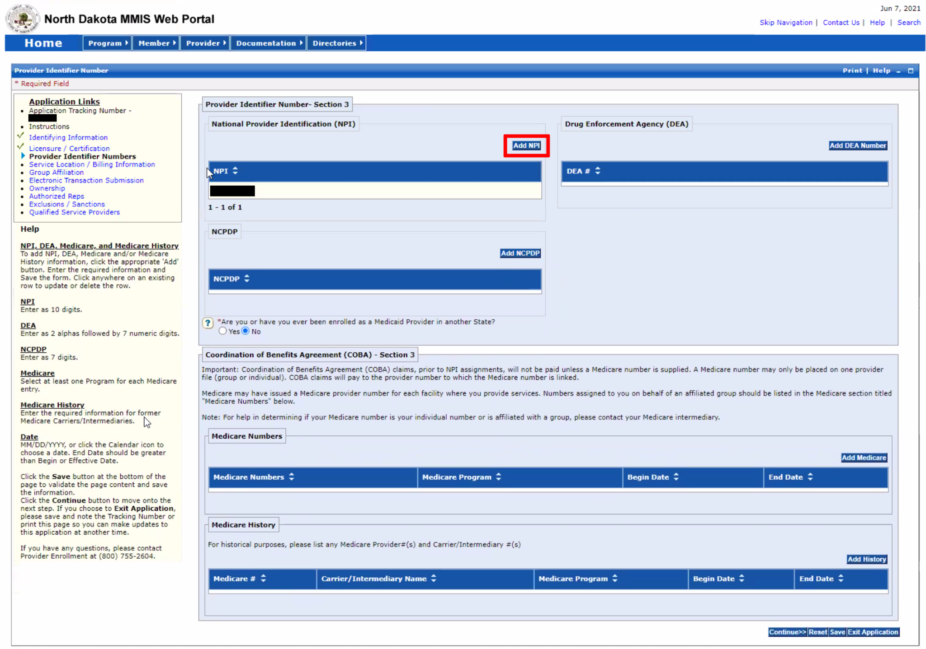

DHS Guidance:

4. Service Location Information
In this section, you will enter your agency’s location information, as well as contact people. You will also be asked about the population you serve, your service area, and billing information including Electronic Funds Transfer (EFT) and Electronic Remittance Advice (ERA) information.

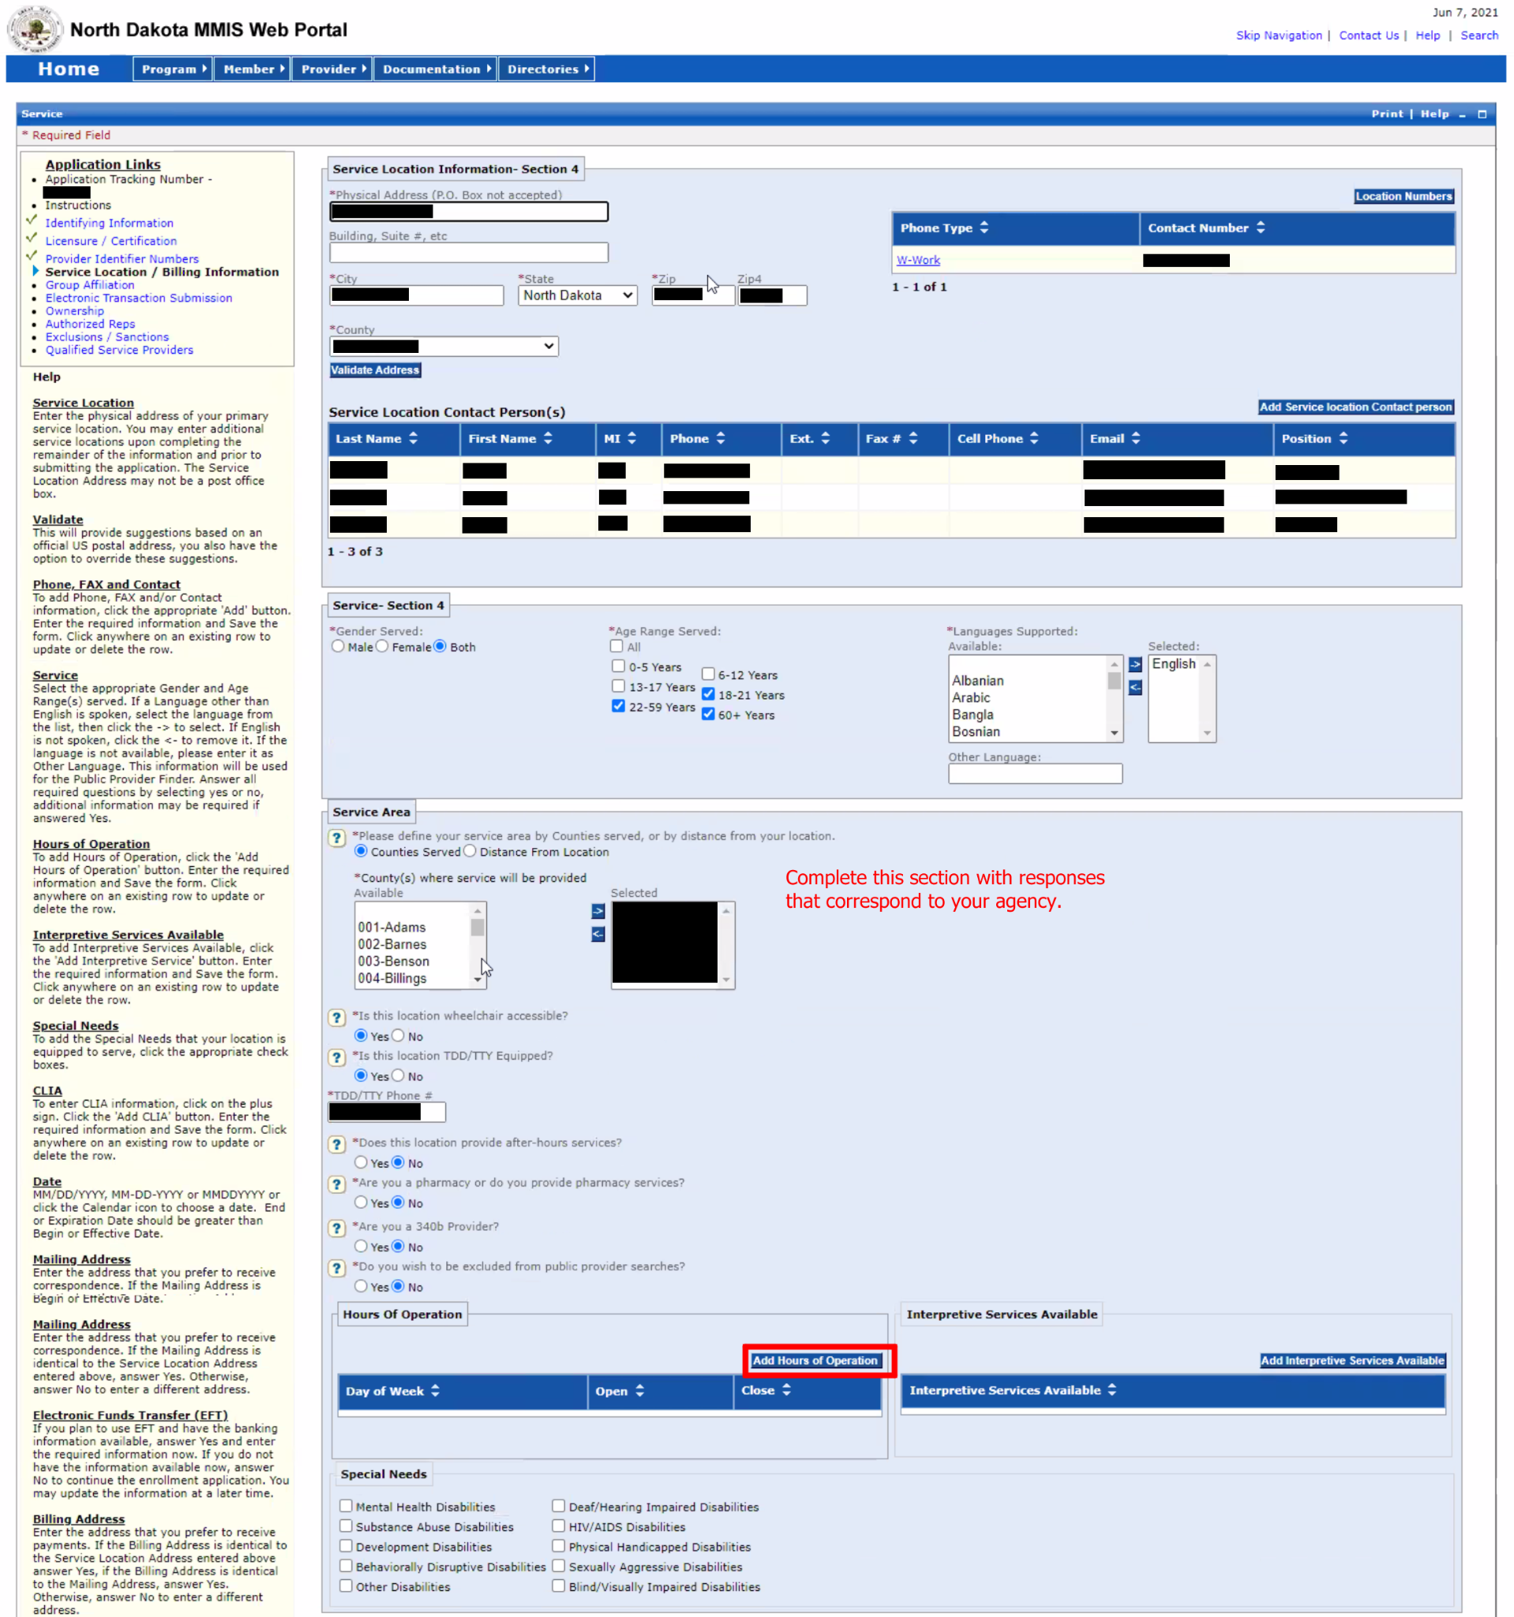
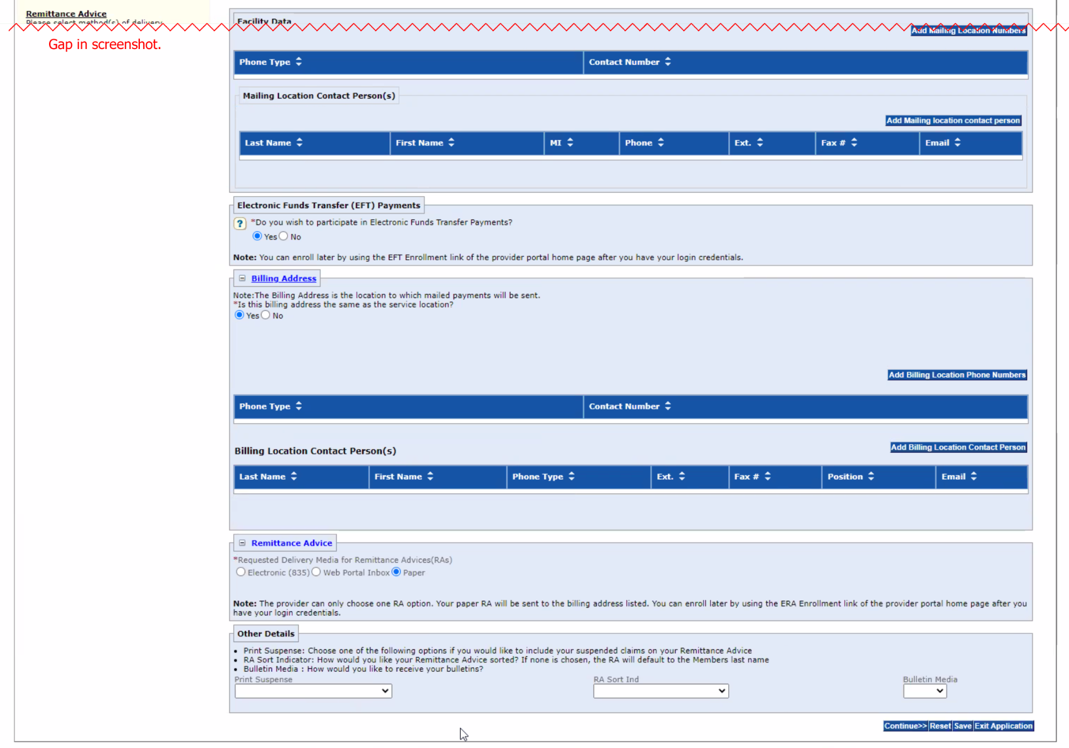

You will also be asked to fill out an EFT form as part of this section. This enables you to be paid when billing for services. The information requested on this page is similar to the information requested in the PDF form SFN 661: Electronic Funds Transfer.

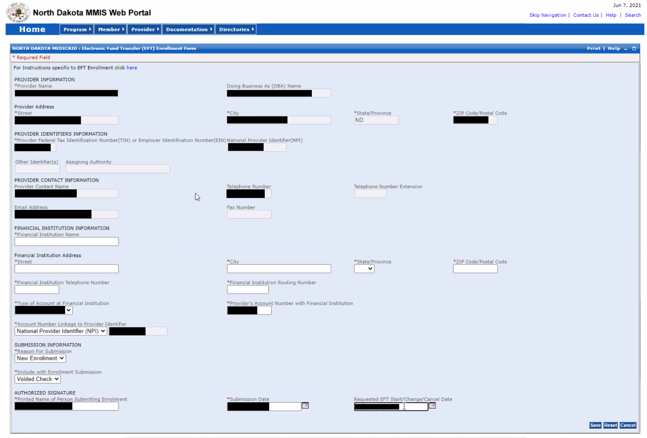

DHS Guidance:
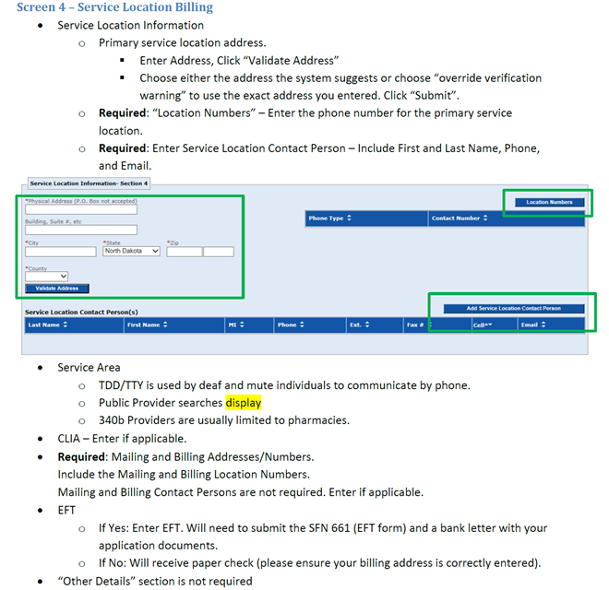

5. Affiliations
In this section, you will enter individuals who are enrolled Medicaid providers who will be providing services. It is likely that your staff will not yet be enrolled to provide 1915(i) services, in which case, you will skip this section.

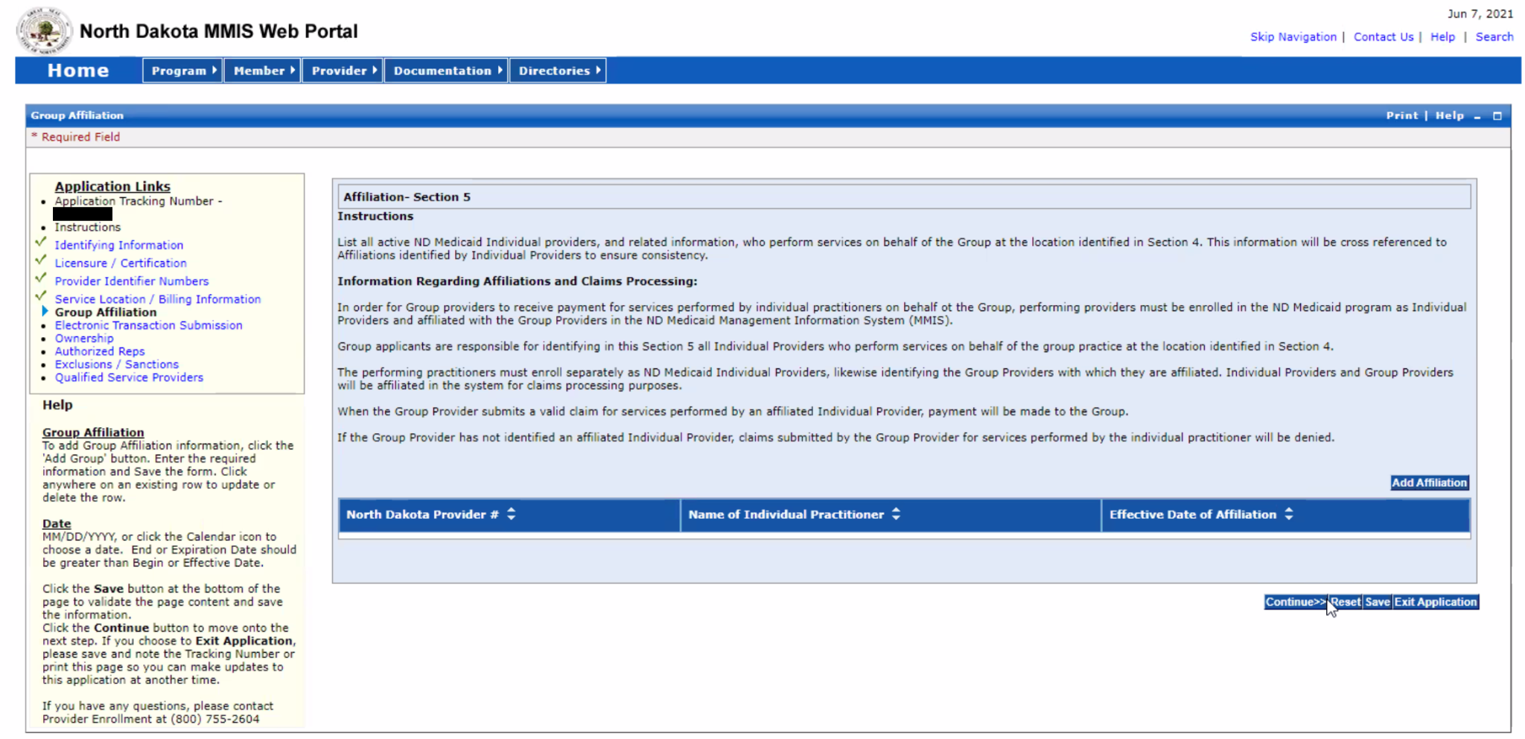

DHS Guidance:

6. Electronic Transaction Submission
In this section, you are asked how your agency would like to submit transactions electronically. Select the option your agency will use.

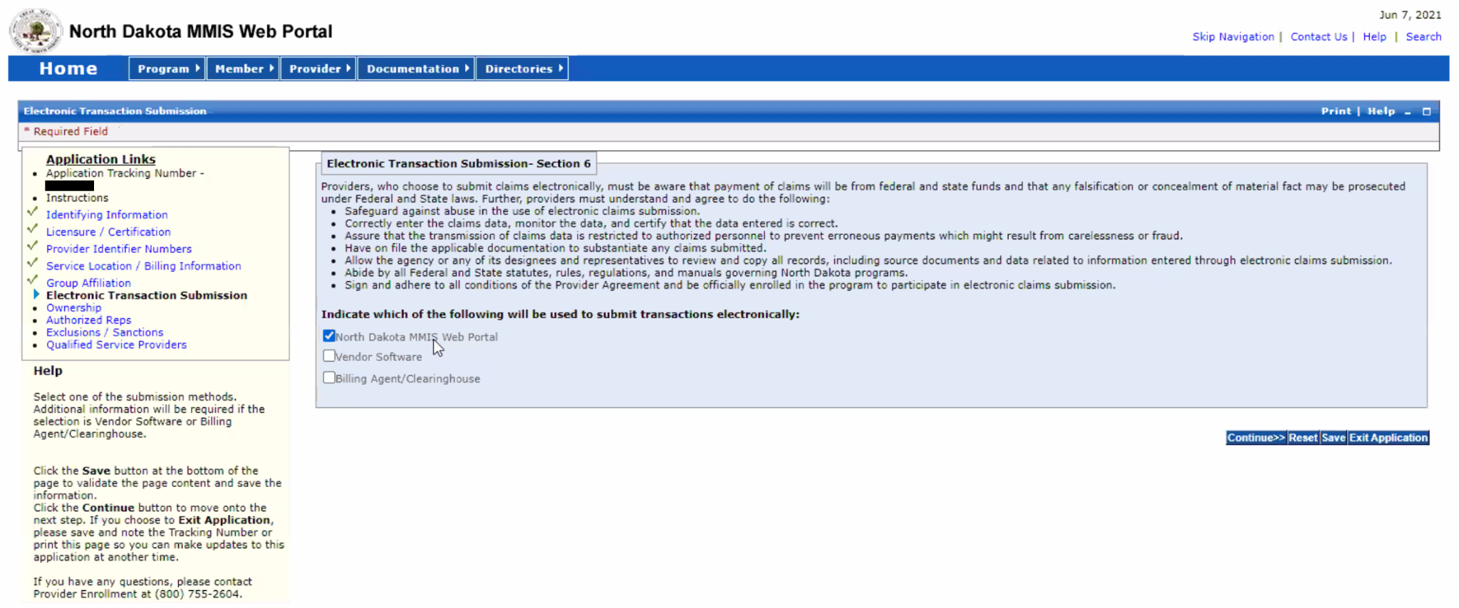

DHS Guidance:
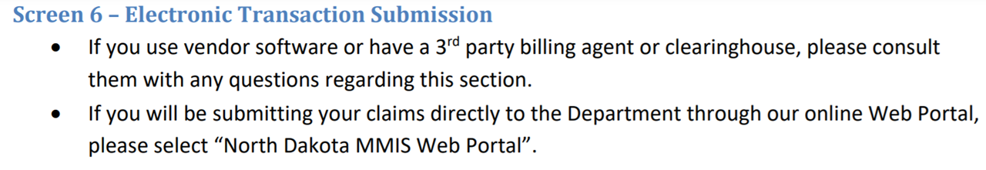

7. Ownership
This section asks about the ownership and managing employees for your agency. Answer as appropriate for your agency. This section of the MMIS Web Portal provider enrollment process resembles SFN 1168: Ownership/Controlling Interest and Conviction Information. The PDF for SFN 1168 includes additional information that may help your agency determine who needs to be listed in this section.

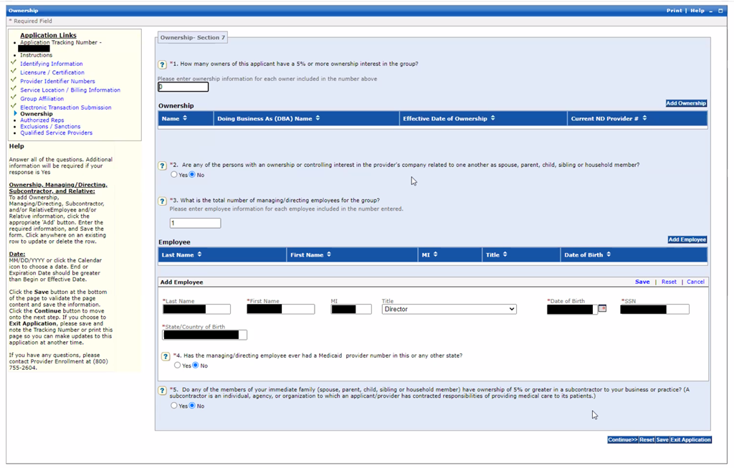

DHS Guidance:
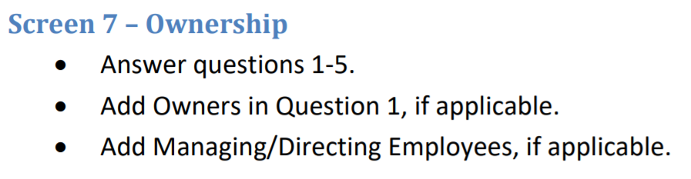

8. Authorized Representatives
In this section, enter all Authorized Representatives. For example, for a nonprofit, you may only need to list your Executive Director, depending on your agency’s structure.

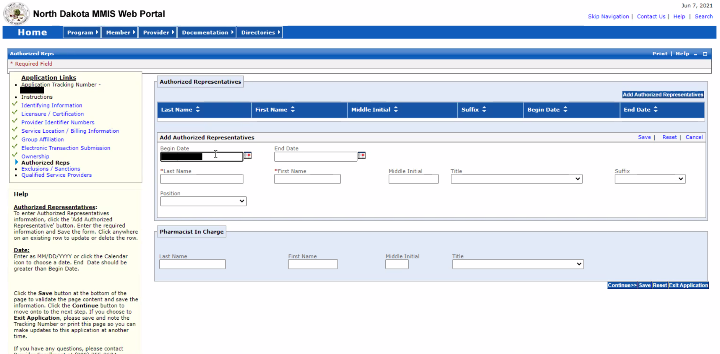

DHS Guidance:
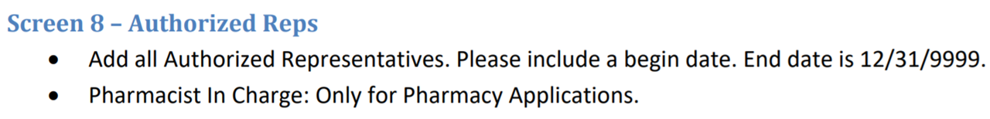

9. Exclusions / Sanctions
In this section, you are asked whether your agency has any exclusions or sanctions. Answer as appropriate for your agency.

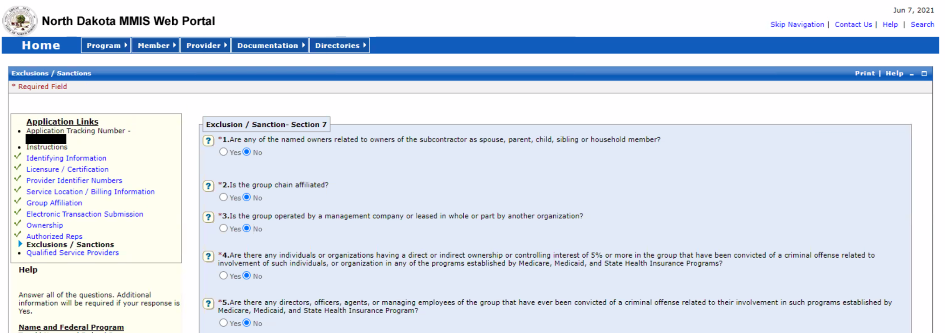

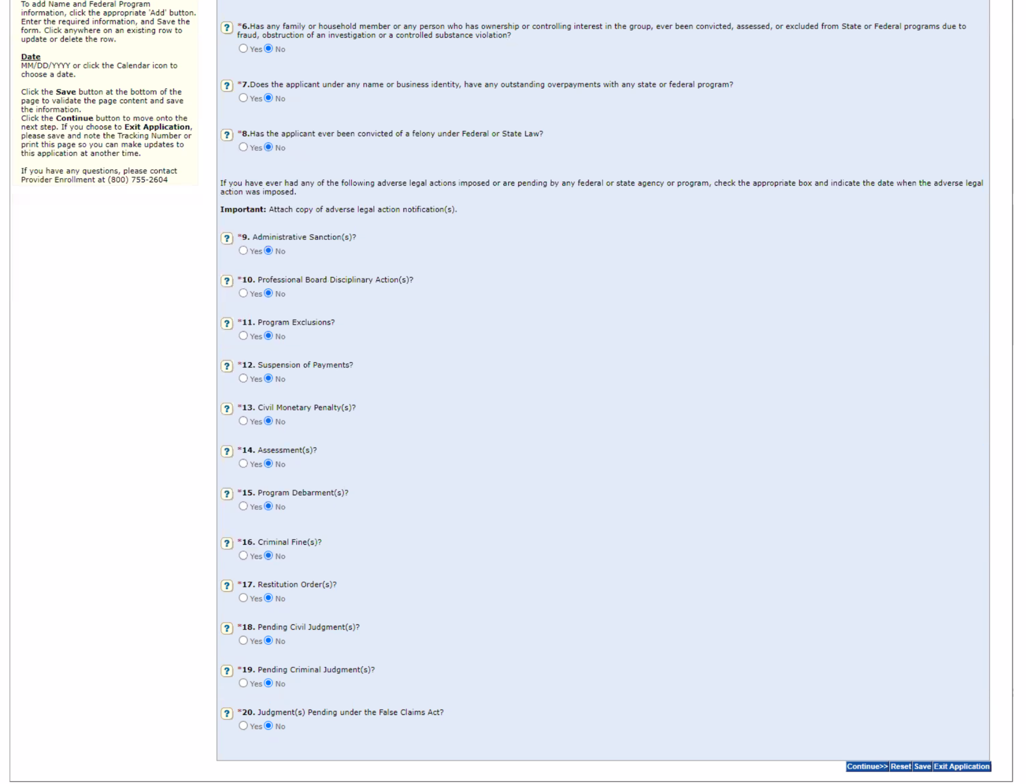

DHS Guidance:
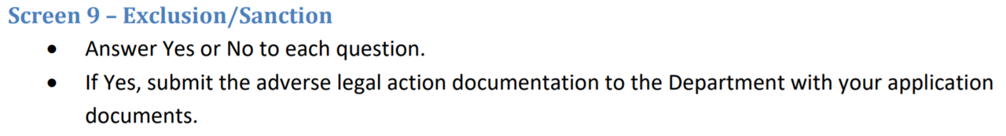

10. Qualified Service Providers
Skip this section.

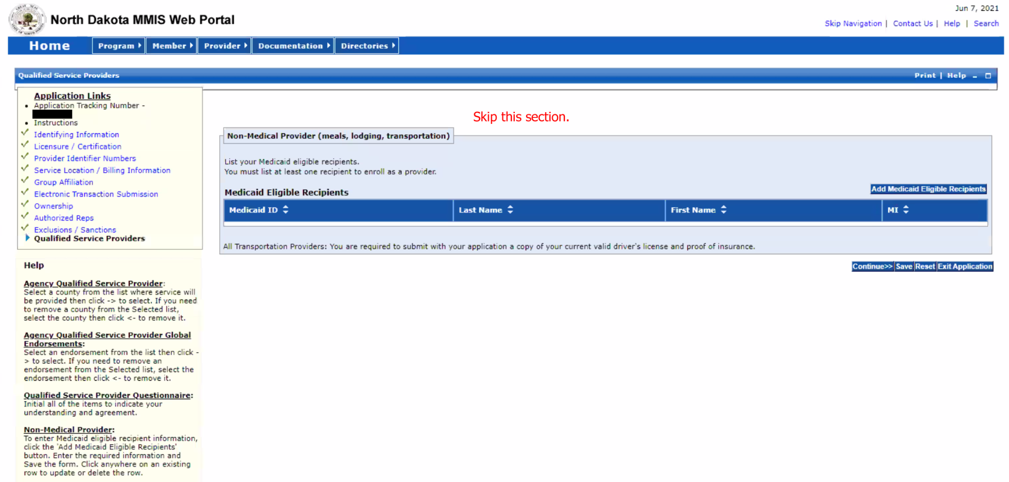

DHS Guidance:
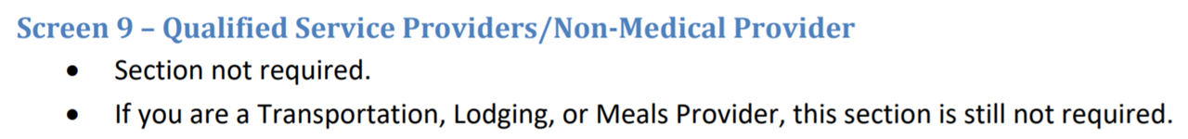

Submitting the Application
Enter all of the information on the first screen. Then, click “Save,” and then “Validate Application.” If there are any errors in your application, the MMIS Portal will show you where the errors are and allow you to correct them.

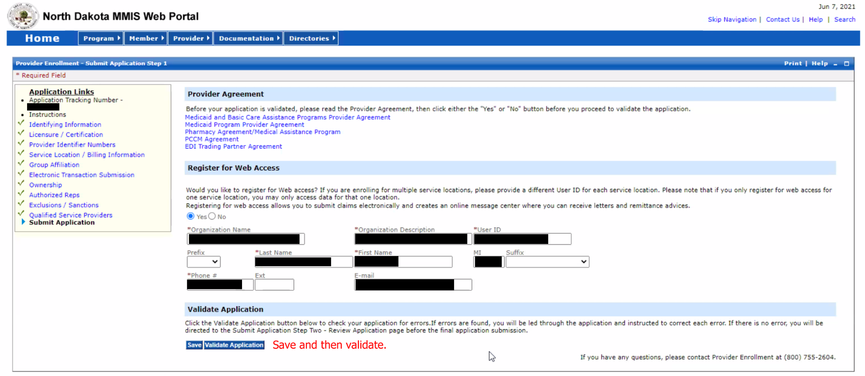

DHS Guidance:

Finally, read through the next page, check the boxes in the Electronic Signature section, and enter the Requested Claim Submission Effective Date (which should match the date listed on your PDF forms). Then, click “Save,” and when you’re ready, click “Confirm Submit.”

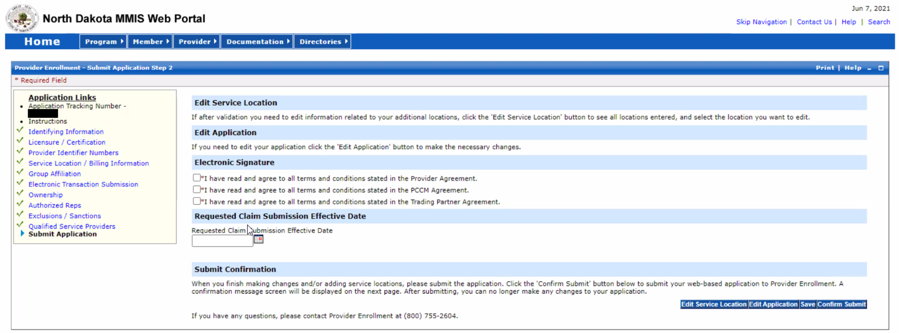

DHS Guidance:
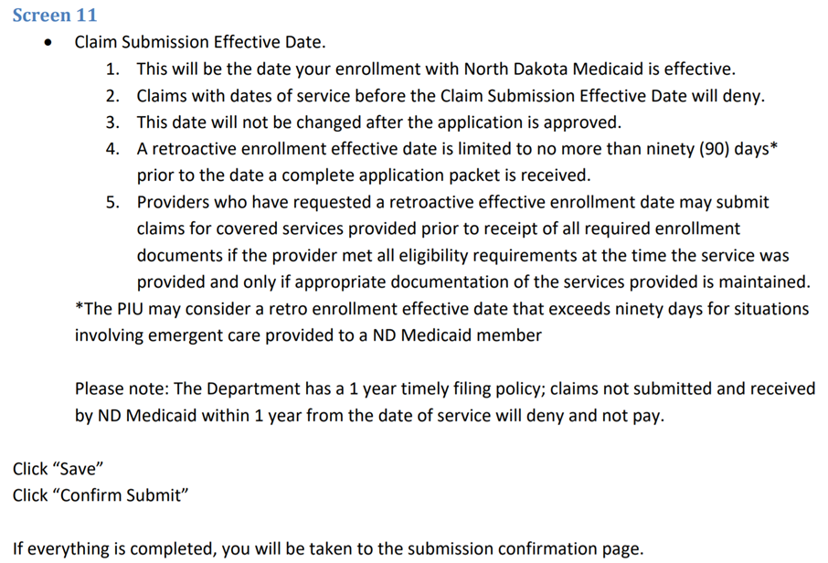

Pulling Up an Incomplete Application & Checking Application Status
You do not have to complete the entire application in one session. As long as you have been assigned an Application Tracking Number, you can resume your application at any time by entering your Application Tracking Number and SSN on the Provider Enrollment homepage of the North Dakota MMIS Web Portal.

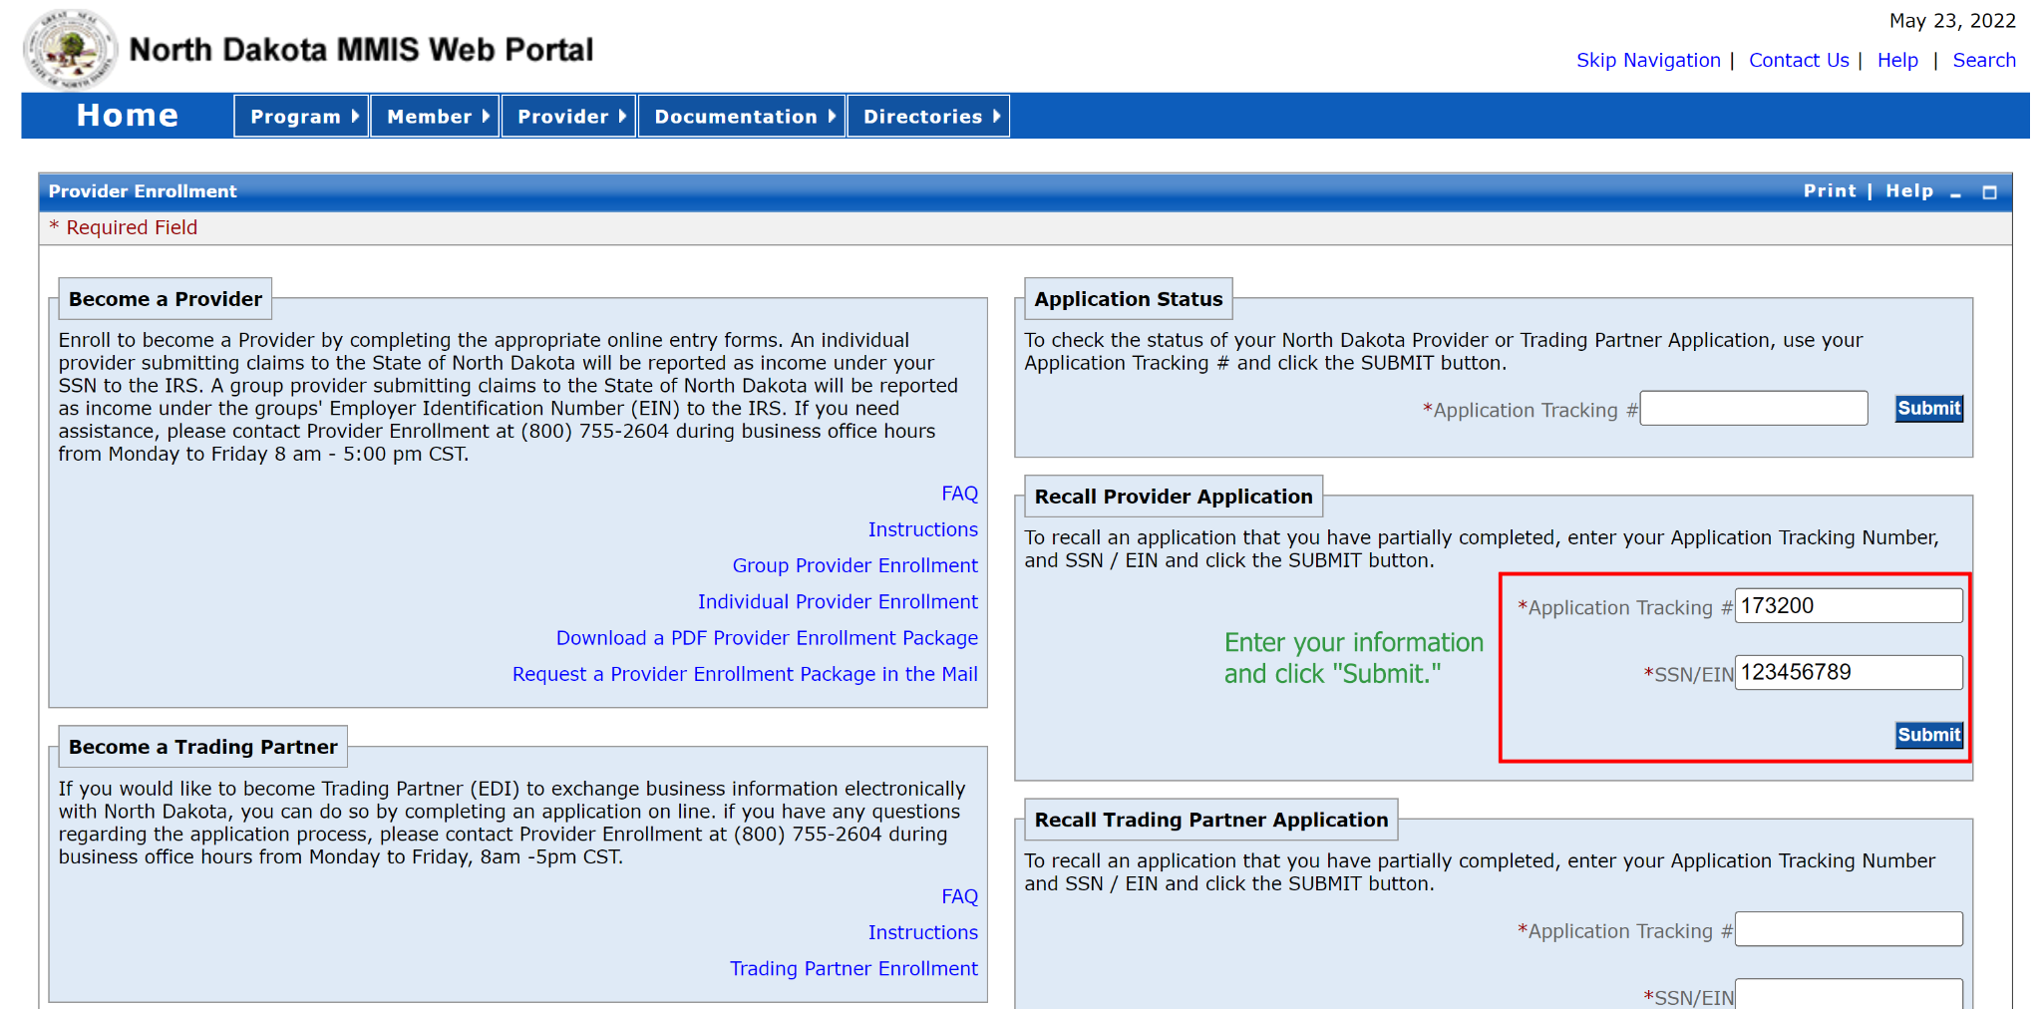

You can also check the application status of a submitted application by entering the Application Tracking Number in the Application Status box on the same page.

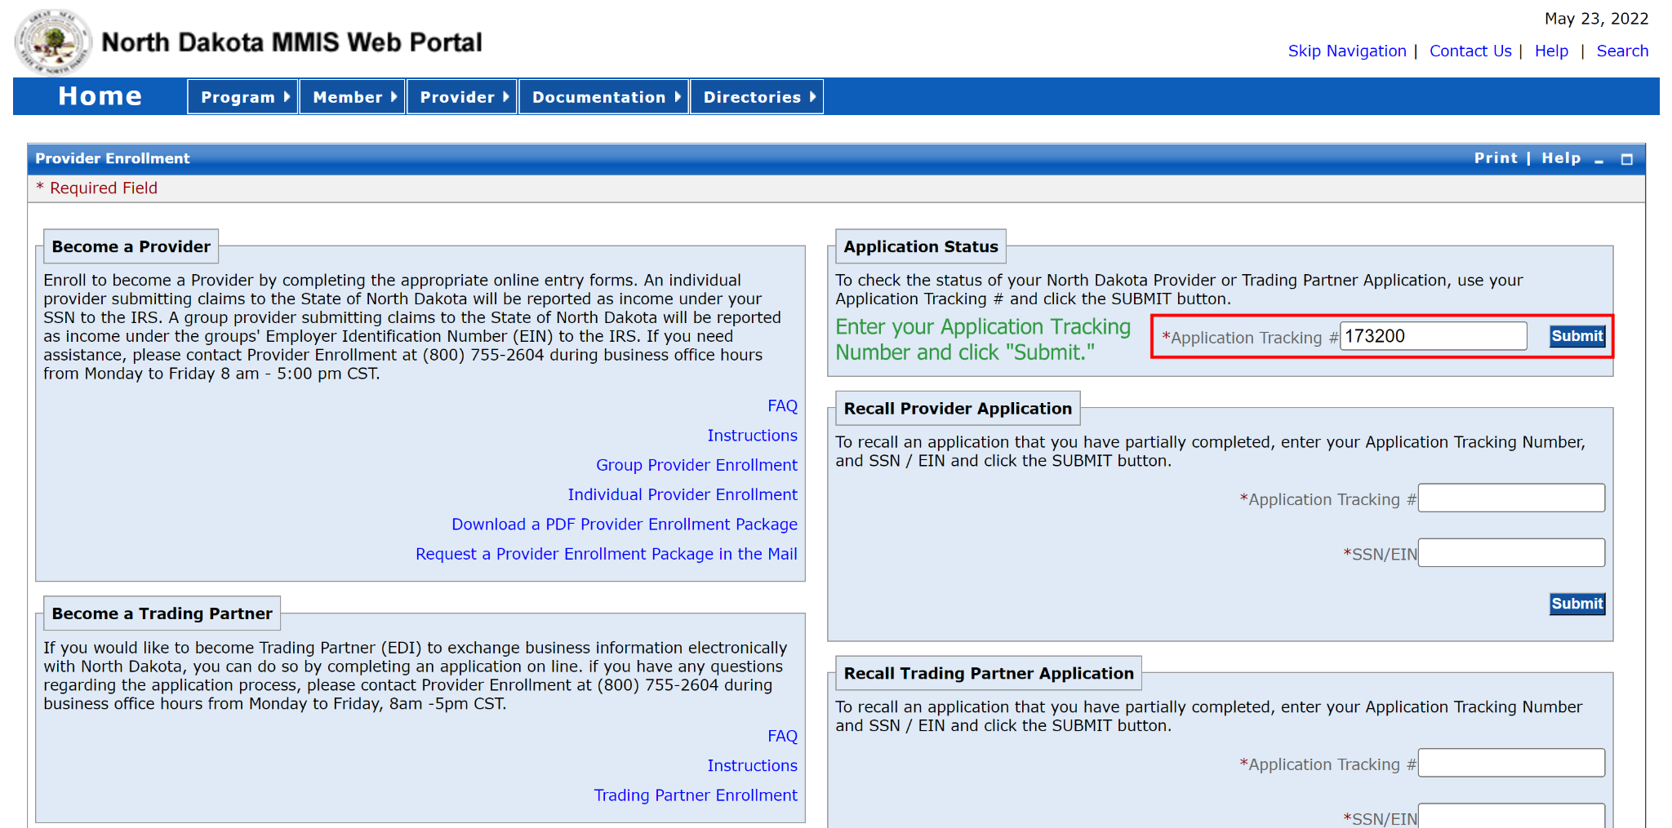

Group Enrollment Step B: PDF Forms
Begin by downloading the Provider Enrollment Checklist from the 1915(i) Process Overview page of the ND DHS Behavioral Health Division website. Scroll to the page entitled “Group Application Checklist” (page 7 of the PDF at the time of writing). We recommend starting by completing this page.

On the next page of the Provider Enrollment Checklist, there is a list of documents that need to be completed and emailed or faxed to DHS. Links are included on page 8 of the Provider Enrollment Checklist PDF for the documents you will need to fill out. For Housing Supports enrollment, you will need to submit the following:
- Coversheet for Fax/Email
- Group Application Checklist (the document with the list itself)
- IF YOU ARE ENROLLING MORE THAN ONE LOCATION: List of Service Locations
- W-9
- IF YOUR AGENCY IS NOT TAX EXEMPT: CP 575/147C
- IF YOUR AGENCY IS TAX EXEMPT: IRS Tax Exempt Letter
- Group Attestation (located within the Group Application Checklist PDF)
- Group License/Certification (for Housing Supports, this is proof of membership in the ND Continuum of Care)
- NPI Printout from the NPPES Website
- SFN 661: Electronic Funds Transfer
  - Bank Letter/Voided Check
- IF YOUR AGENCY IS OUT-OF-STATE: SFN 509: Out of State/Out of Network Enrollment Clarification
- SFN 1168: Ownership/Controlling Interest and Conviction Information
- SFN 615: Medicaid Program Provider Agreement

The remainder of this section will walk you through completing the provider enrollment process, including screenshots of the forms filled out for a fictional nonprofit. We recommend completing the coversheet last as it asks for the total number of pages in your application.

After completing these forms, you must submit them to ND Medicaid Provider Enrollment via secure email or fax to:
- Email: NDMedicaidEnrollment@Noridian.com (please do not send EFT information, dates of birth, or Social Security Numbers by unsecured email)
  - For those providers that wish to send the required documentation via email, you must request access to a secure link by sending an email to NDMedicaidEnrollment@noridian.com. An email will be sent back to you with a link to a secure site to send your documents to the enrollment application.
- Fax: (701) 433-5956 ATTN: NDM Provider Enrollment

REQUIRED: 1. Coversheet for Fax/Email
You must include a coversheet for your provider enrollment application. DHS provides a coversheet that you may use, or you may use your own as long as it contains all of the same information as the DHS template. This template can be accessed via the link on page 8 of the North Dakota Medicaid 1915i Application/Reactivation Checklists PDF file.

Note that the application tracking number will not be generated until you start your application on the North Dakota MMIS Web Portal. We recommend completing this document last because it asks for the total number of pages in your application.
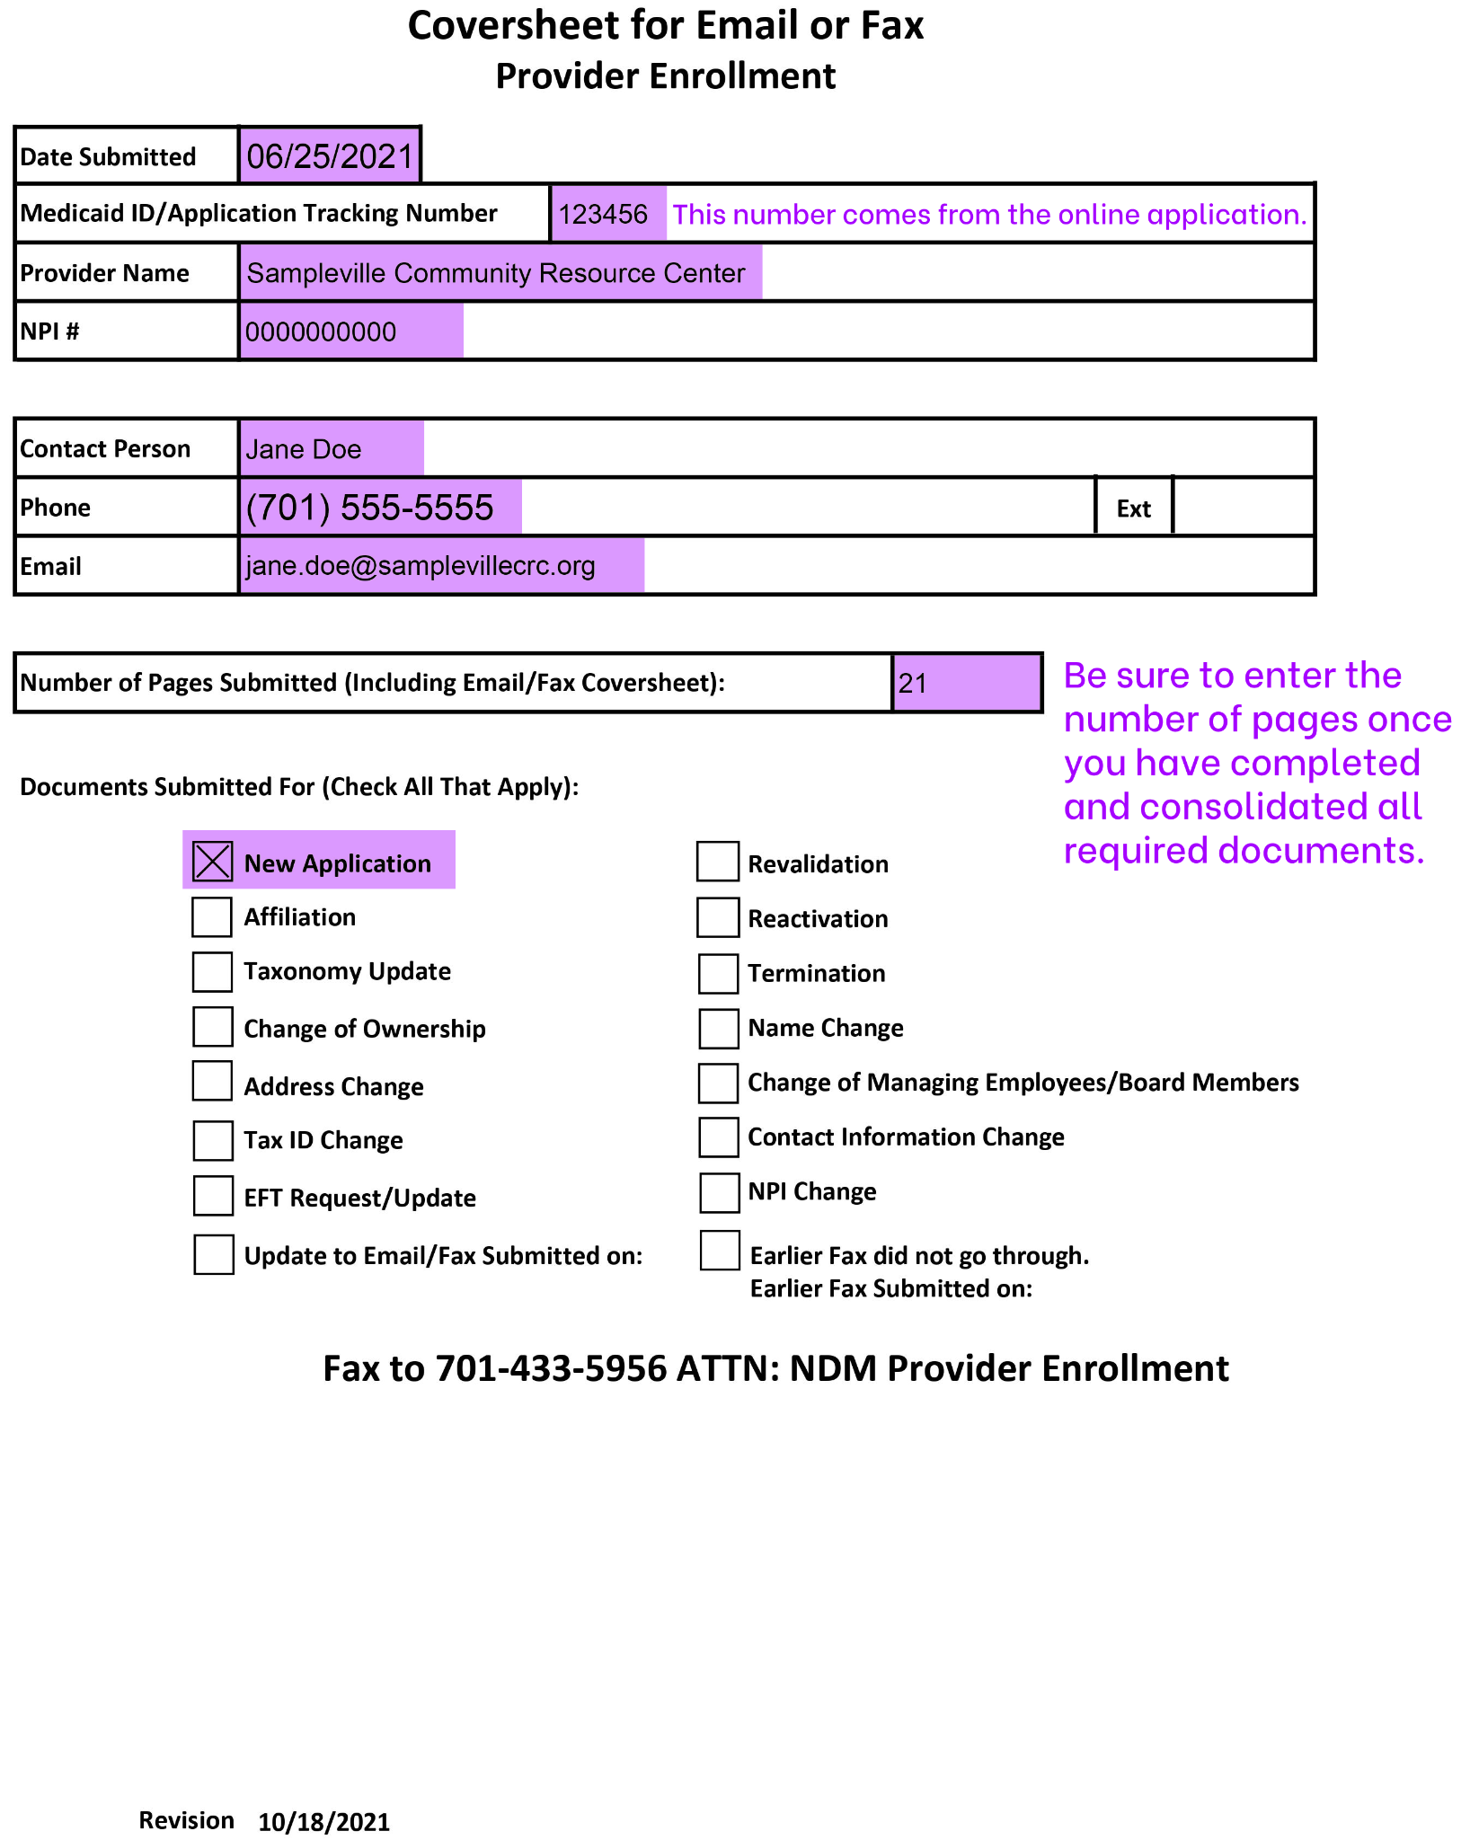

REQUIRED: 2. Group Application Checklist
We recommend starting with this document. In the January 2022 version of the North Dakota Medicaid 1915i Application/Reactivation Checklists PDF file, the pages your agency will need to fill out for the group application are pages 7-8 (example shown on the following page). Note that the application tracking number will not be generated until you start your application on the North Dakota MMIS Web Portal.
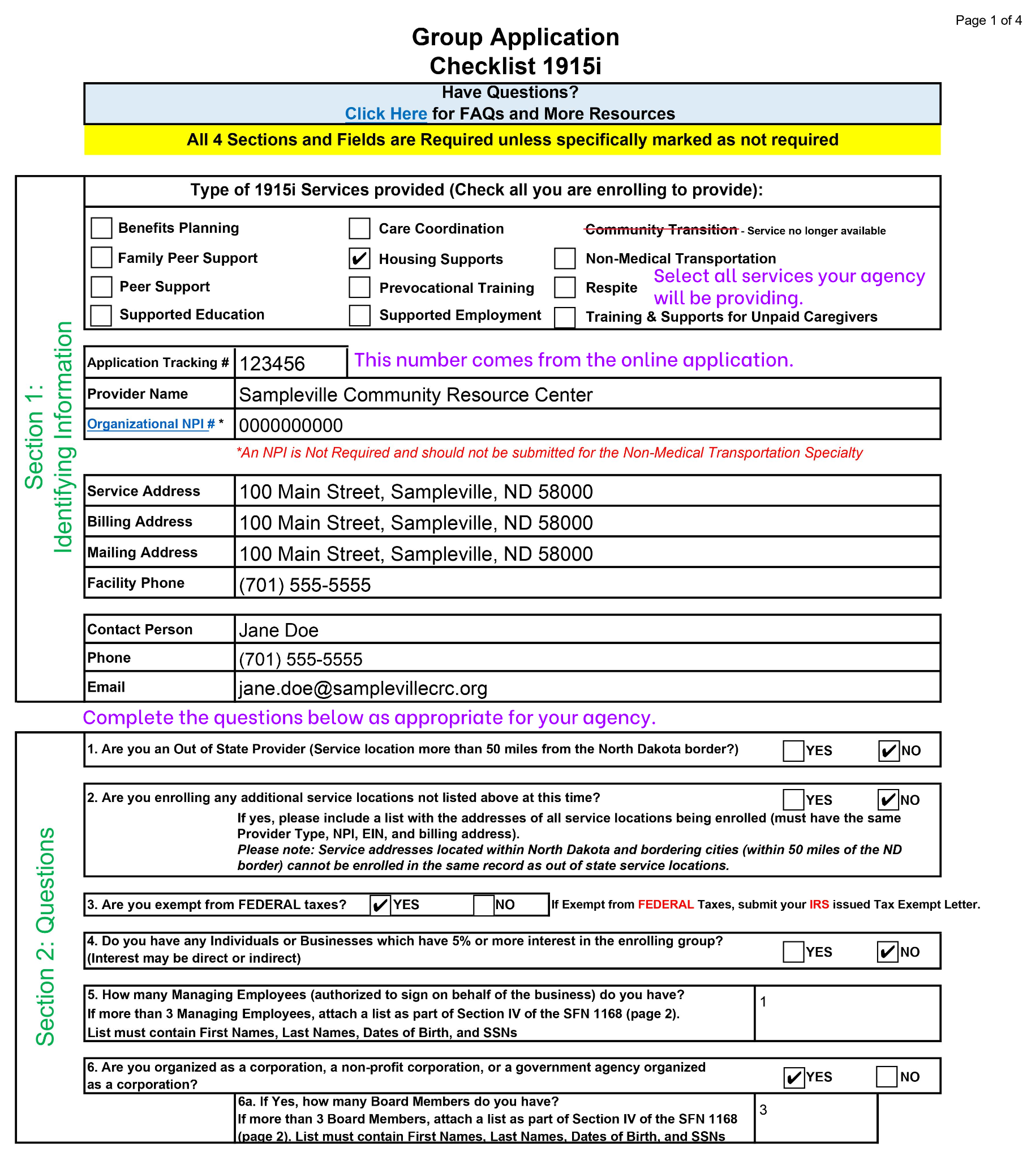
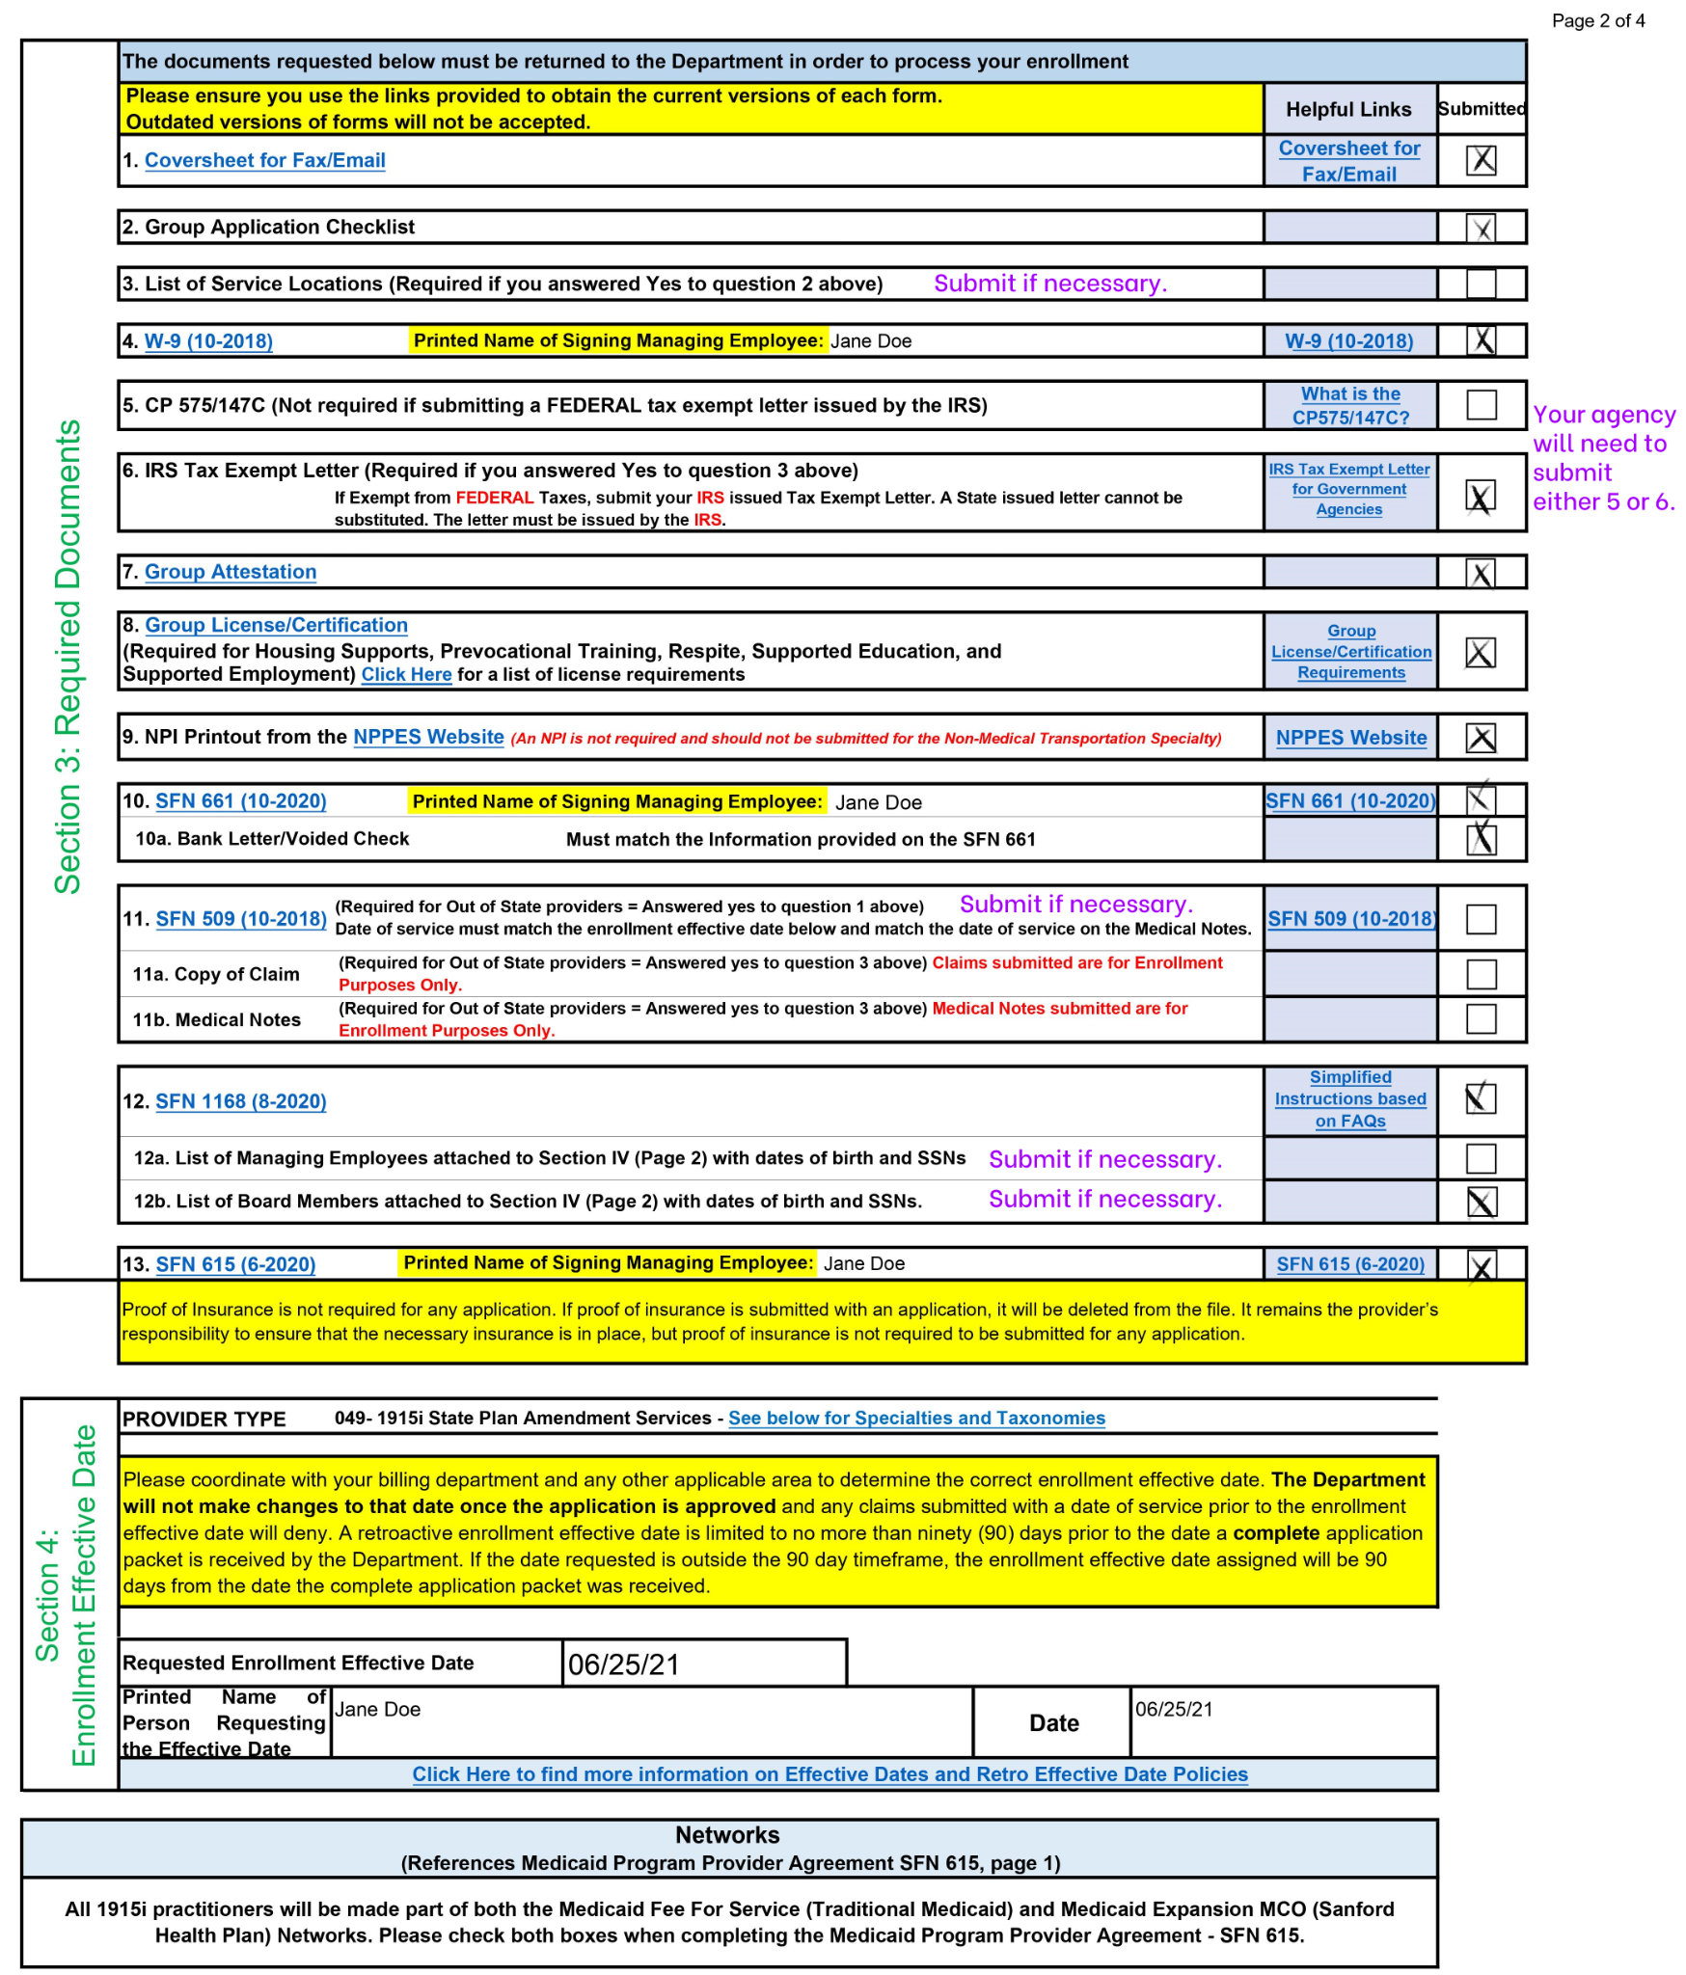

POSSIBLE: 3. List of Service Locations
If your agency is enrolling more than one service location, you must include a list with the addresses of all service locations being enrolled. These locations must have the same Provider Type, NPI, EIN, and billing address. The Group Application Checklist includes the following note: “Please note: Service addresses located within North Dakota and bordering cities (within 50 miles of the ND border) cannot be enrolled in the same record as out of state service locations.”

REQUIRED: 4. W-9
Complete a W-9.

POSSIBLE: 5. CP 575/147C
This item applies to agencies that are not tax exempt. CP 575 is an IRS-issued form that confirms that your agency has been granted an Employer Identification Number (EIN). A 147C is an IRS-issued EIN verification letter. You will need to include a copy of one of these forms in your application if your agency is not tax exempt.

POSSIBLE: 6. IRS Tax Exempt Letter
If your agency is tax exempt, you must include your IRS-issued Tax Exempt Letter. You cannot use a State-issued tax exempt letter.

REQUIRED: 7. Group Attestation
The Group Attestation is located within the Group Application Checklist. Clicking “Group Attestation” in the Group Application Checklist will take you to the corresponding page with the Group Attestation form. An example of how to complete this form is included on the following page.

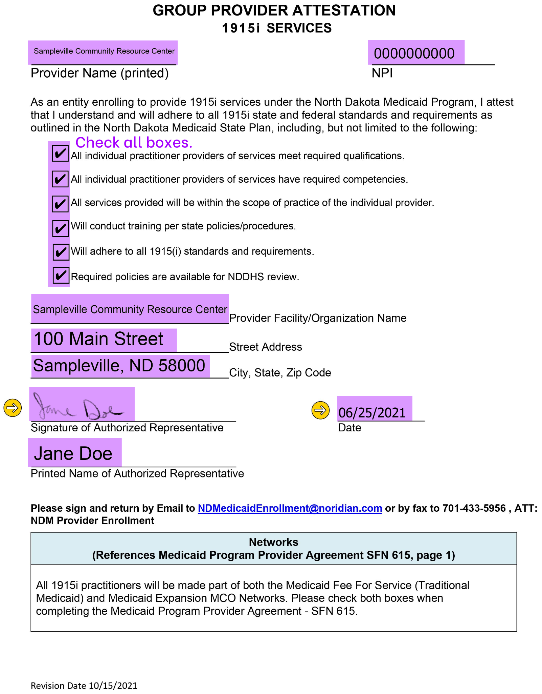

REQUIRED: 8. Group License/Certification
Agencies enrolling to provide Housing Supports must be a member in the North Dakota Continuum of Care (NDCOC). The membership list as of March 2021 is available here. Please confirm that your agency is a member of the NDCOC and include a copy of the latest version of the membership list in your provider enrollment application.

If your agency is also applying to provide Prevocational Training, Respite, Supported Education, or Supported Employment, you must submit documentation of the following (from page 9 of the North Dakota Medicaid 1915i Application/Reactivation Checklists PDF file):
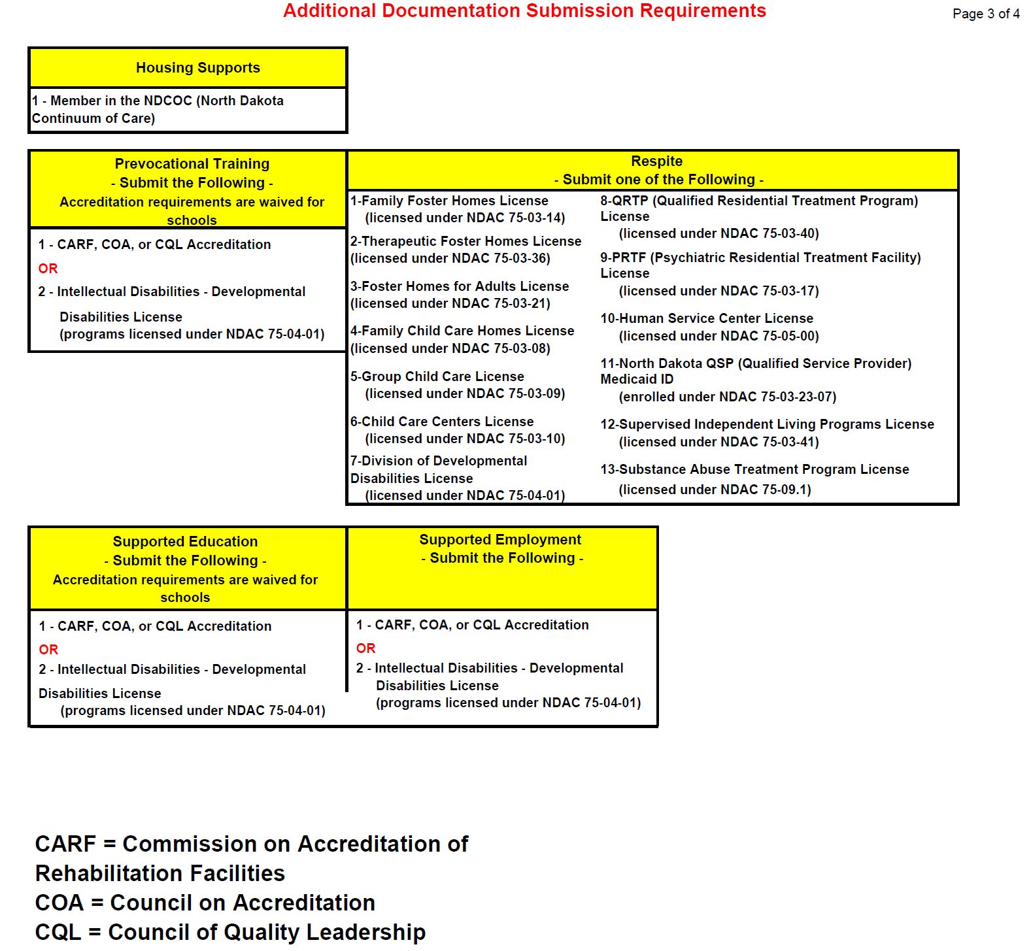

REQUIRED: 9. NPI Printout from the NPPES Website
You must include documentation of your agency’s NPI. This can be obtained from the National Plan & Provider Enumeration System (NPPES) website. An example of what this document looks like is shown below.
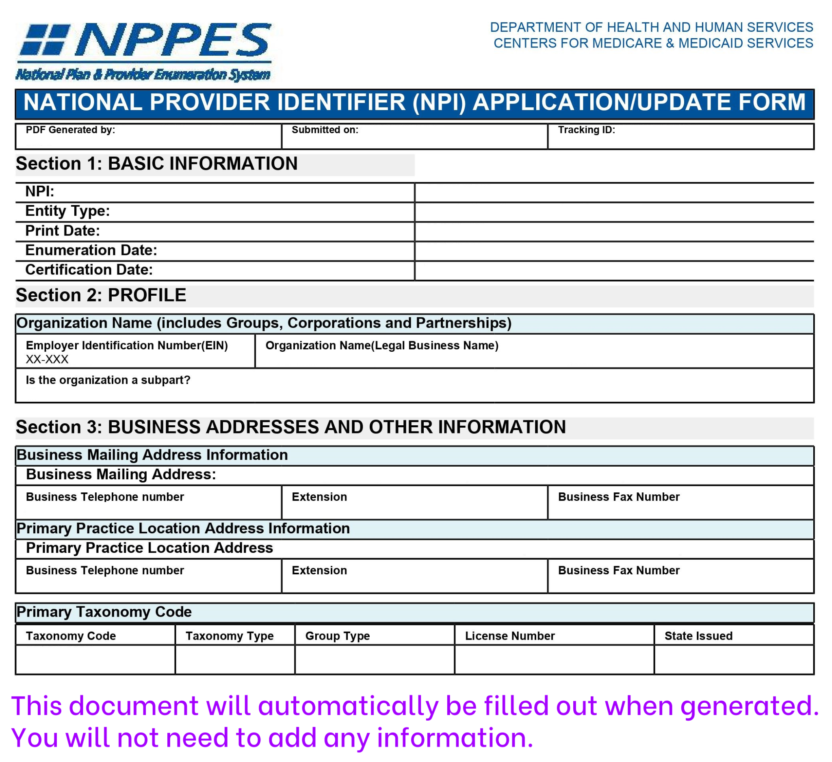

REQUIRED: 10. SFN 661: Electronic Funds Transfer
SFN 661 sets your agency up for Electronic Funds Transfer from DHS. This form is essential to ensure your agency can bill for services. An example of how to complete this form is included on the following page.

Along with SFN 661, you must include either a bank letter or voided check.

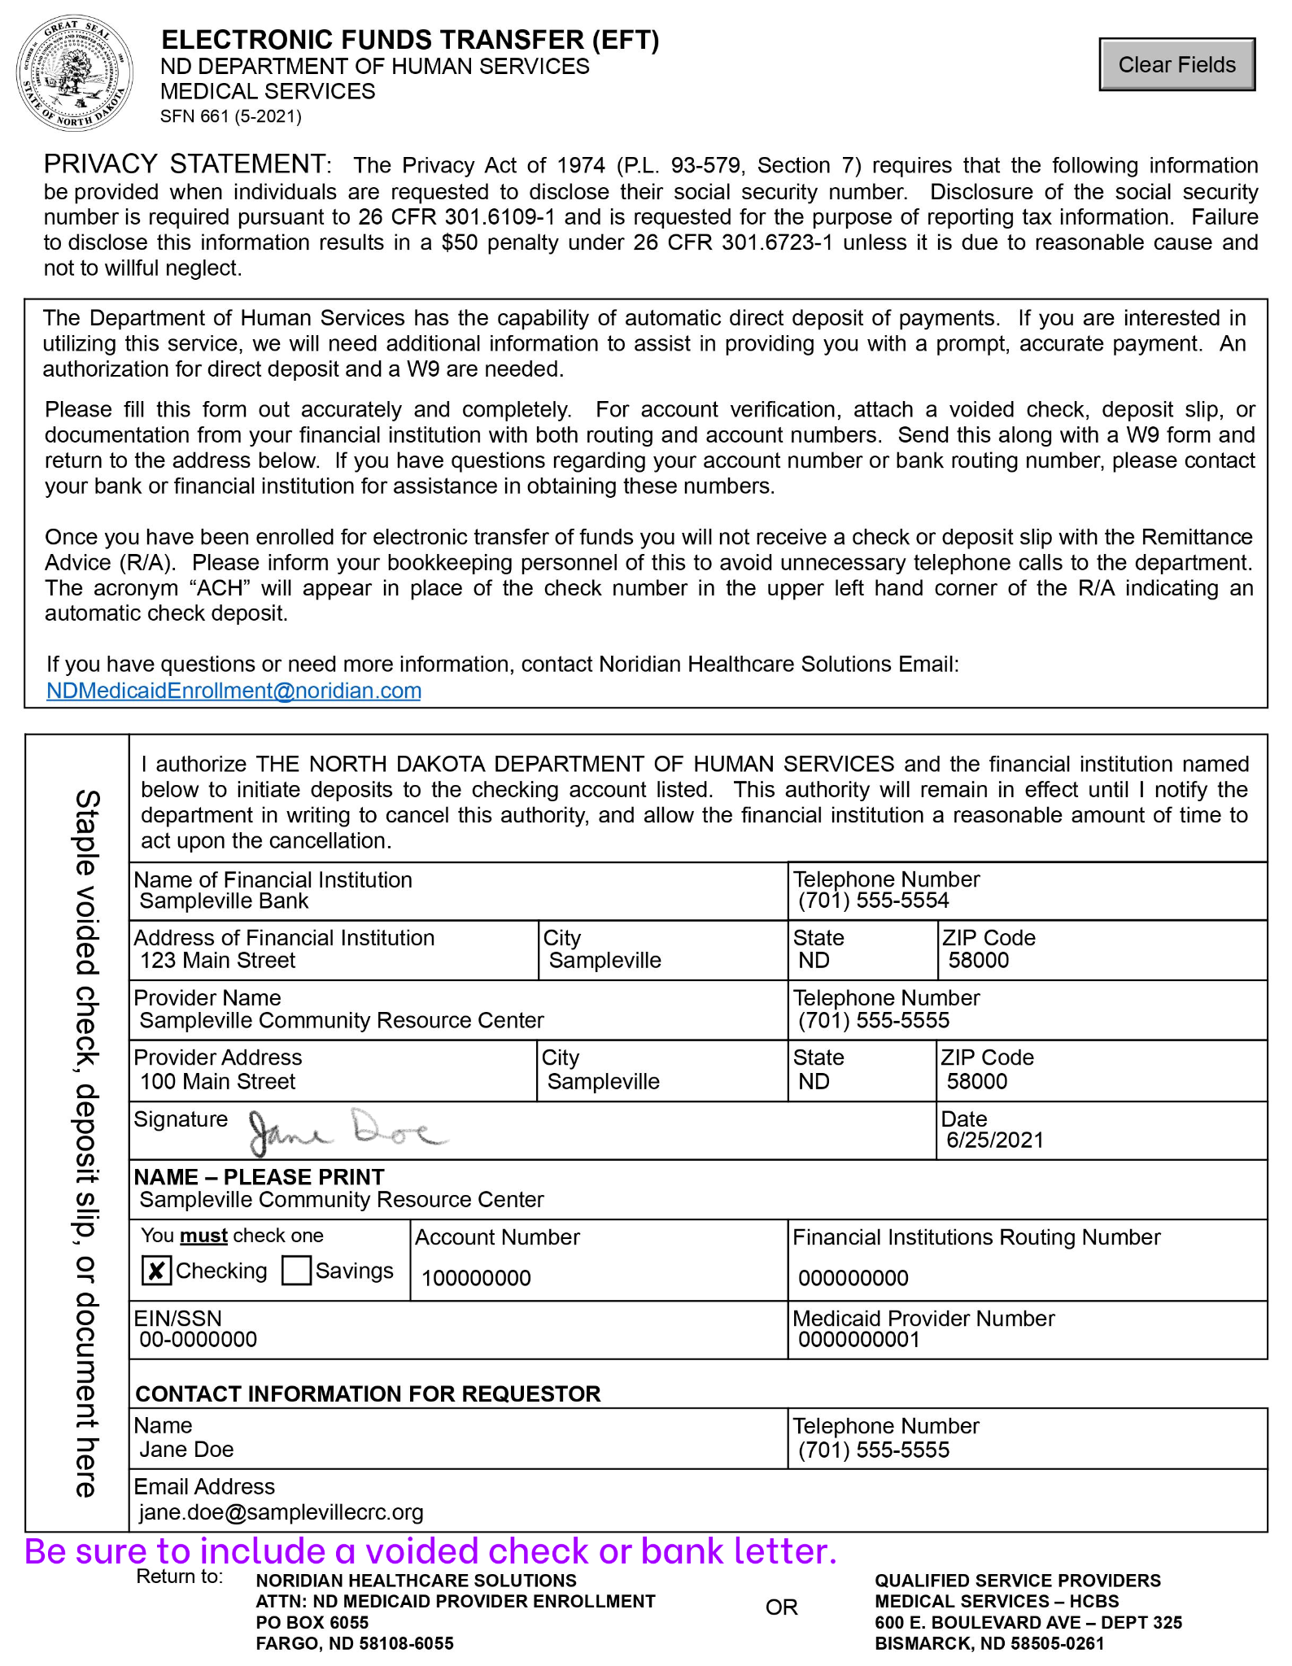

POSSIBLE: 11. SFN 509: Out of State/Out of Network Enrollment Clarification
If your agency is located out-of-state, you will need to complete SFN 509. This is the Out of State/Out of Network Enrollment Clarification. An example of a completed version of this form is on the following page. This form states: “Out of state or network facilities must have at least one Medicaid or Medicaid Expansion-eligible recipient they will be billing North Dakota Medicaid for services to be or already rendered.”

Along with this form, you will need to submit “medical documentation to support care delivered to the North Dakota recipient, not to exceed 30 pages.”

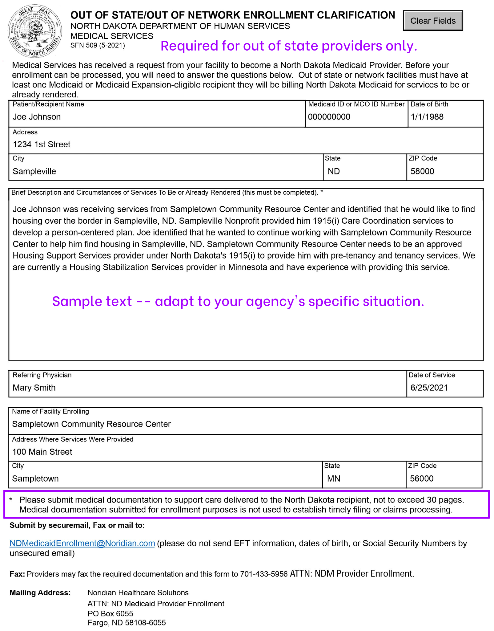

REQUIRED: 12. SFN 1168: Ownership/Controlling Interest and Conviction Information
SFN 1168 asks for Ownership/Controlling Interest and Conviction Information. This information is mandatory to comply with program guidelines set by the Centers for Medicare and Medicaid Services, Department of Health and Human Services. You will need to include the names, dates of birth, addresses, and SSNs of managing employees, board of directors members, trustee members, personnel authorized to sign on behalf of the organization, individuals who have signed any legal documents for this organization, and owners. If an owner is an organization, you will need to list that organization’s TIN. If your organization is a nonprofit, you will list the nonprofit as the owner.

You may need to attach additional pages to this form if all of the individuals/organizations do not fit in the space allotted on the form itself. Be sure to check the check boxes indicating whether you are attaching additional pages.

Additional instructions for how to complete this form are included on pages 4 and 5 of the form itself, as well as in this document from DHS.

An example of how to complete this form for a nonprofit is included on the following pages.

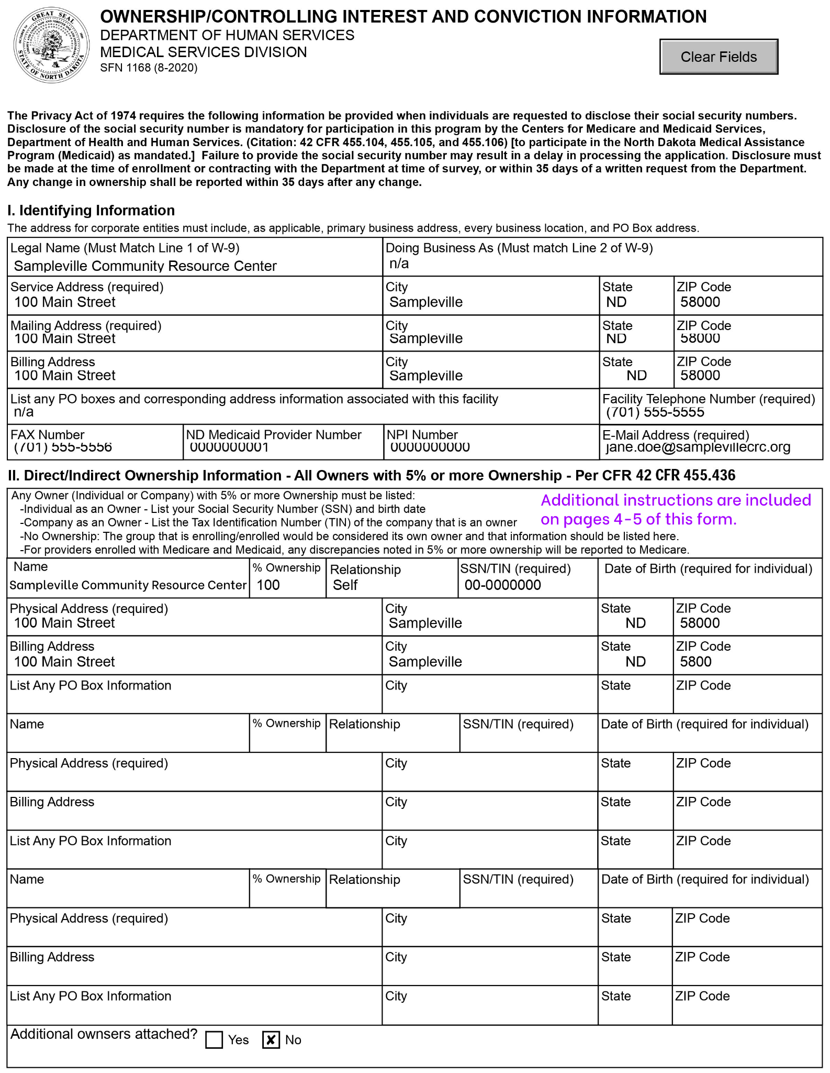
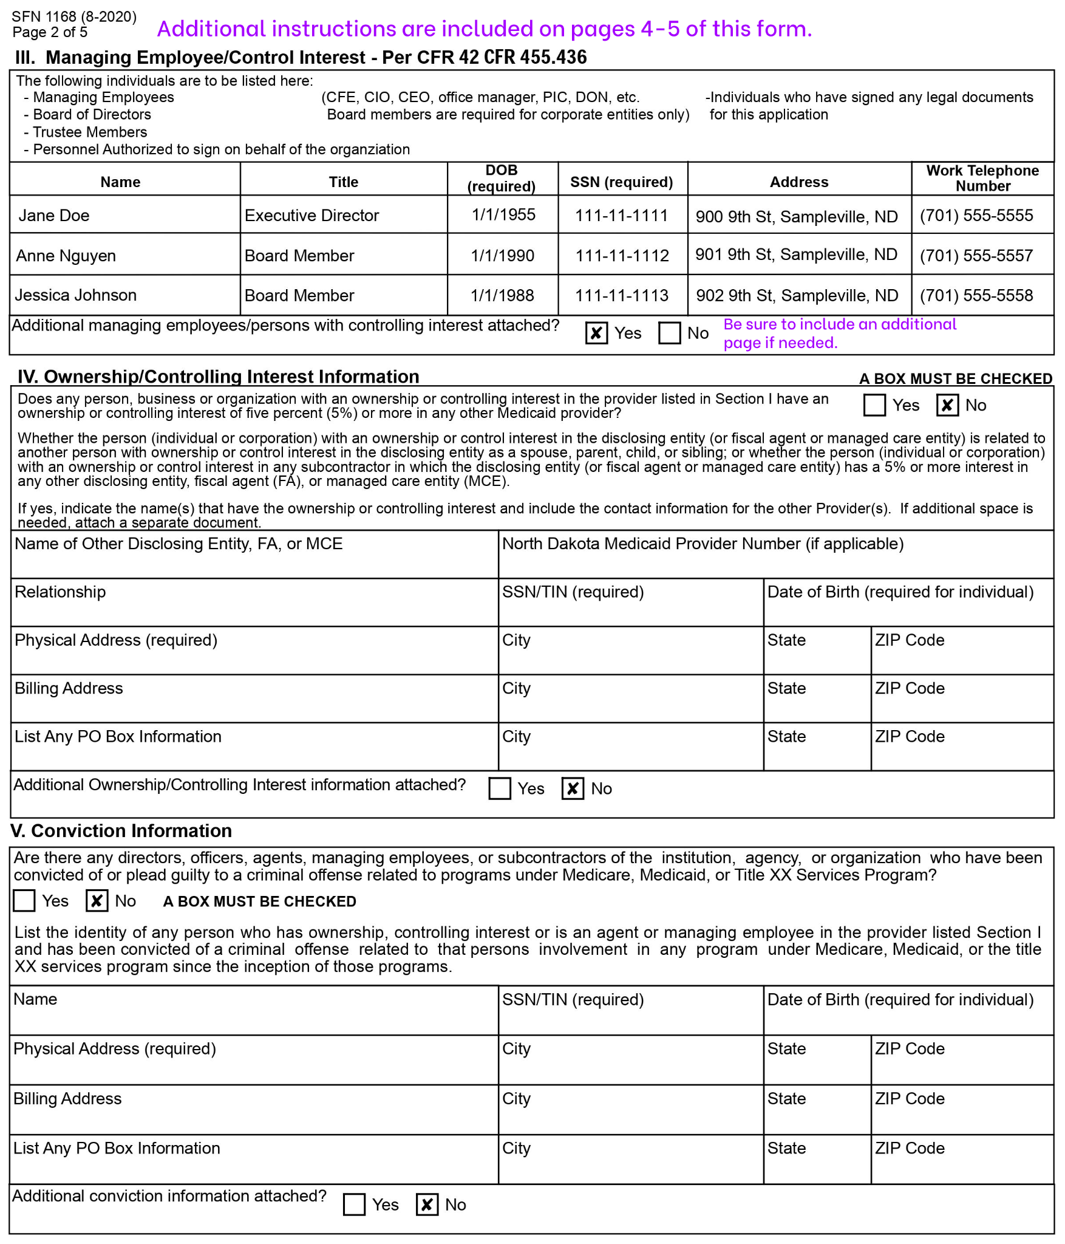
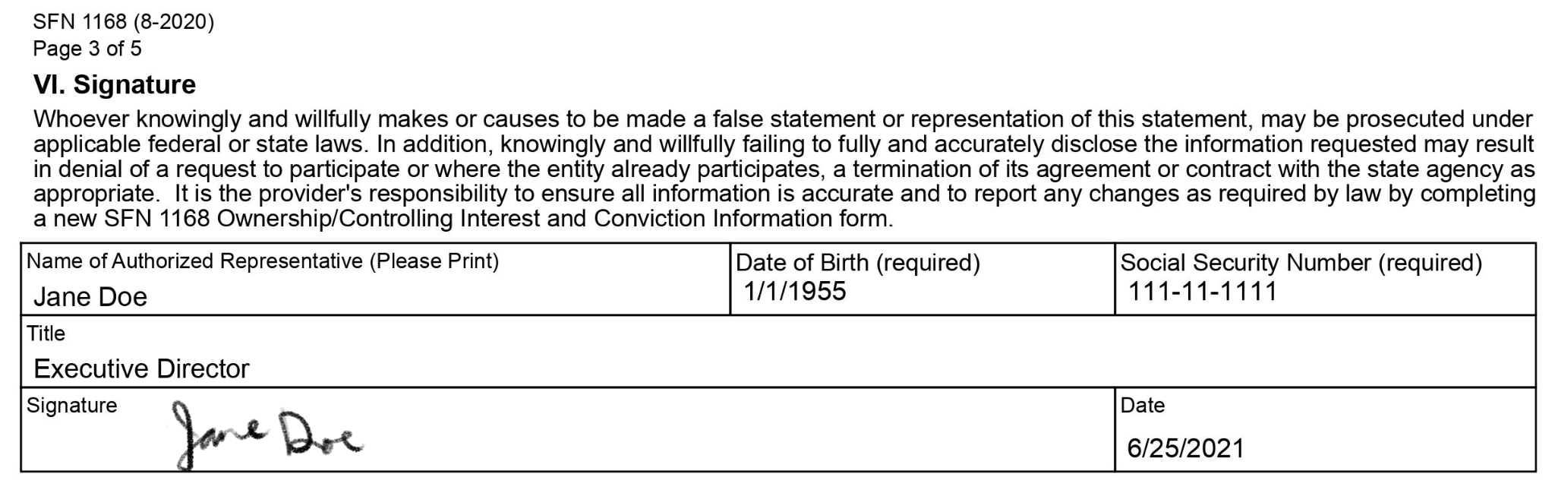

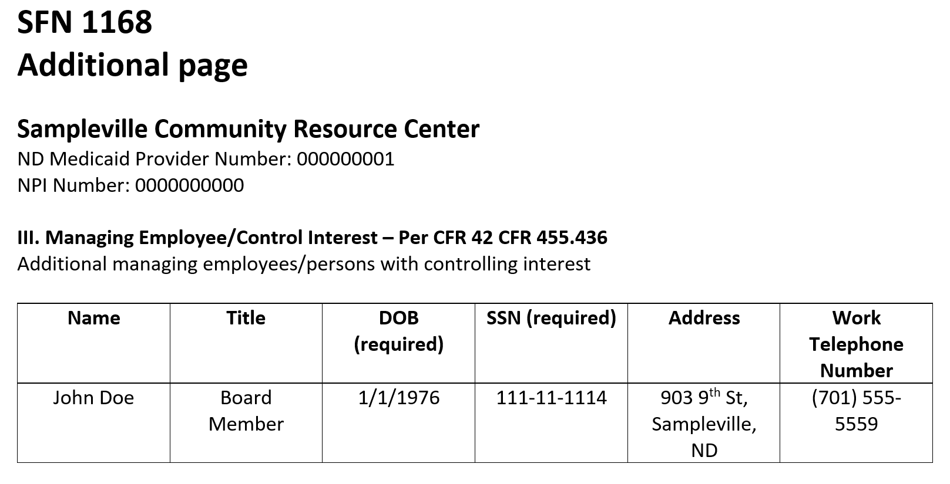
**This additional page is an example of how you could format additional pages from scratch if your agency needs to include additional information with SFN 1168. You do not need to follow this exact formatting.

REQUIRED: 13. SFN 615: Medicaid Program Provider Agreement
This form is required. By signing this form, providers agree to follow the Medicaid Program rules detailed in the document.

